

Engineray-engineer user

COS80029 TAP



Xin wu (Serena)

103792203

Table of Contents

Project Description 2

User Manual 3

Preparation 3

1. Update their personal profile. 5

2. Upload their profile image. 8

3. Upload a resume. 10

4. Set their work availability. 11

5. Complete a Personality Test 17

6. Set their interview availability. 20

7. Attempt at least 3 exams. 24

8. Record at least 2 problem-solving videos. 28

9. Attempt at least 3 mock interviews. 32

After The Preparation 33

1. Attend the interviews and leave feedback for the interview process. 33

2. Accept/Reject the offer received from the company. 35

3. Sign the contract digitally. 36

4. Receive payment from EngineRay 37

TAP EngineRay Project

# Project Description

The purpose of this project is to build and develop a website called *EngineRay,* a job search and recruitment platform designed for multiple companies and engineers who are job seekers. Engineers can create their own profiles, which will be enriched by the vetting data generated by *EngineRay*. Companies as employers can search and evaluate candidates' profiles based on certain criteria. In addition, the client *EngineRay* will have access to this data and act as an administrator. This report will focus on analyzing the requirements of the project in order to determine the appropriate solution to meet the client's needs.

# User Manual

## Preparation

After engineers logged in, they will land on the dashboard page and will need to complete a series of tasks to make them visible for companies. They can always go back to dashboard page by simply clicking on the “***EngineRay***” logo on the left top corner.

Engineers can logout at any time by clicking on the “**Logout**” button on the right corner of the top. They will be logged out and redirected to the main page of *EngineRay* website*.*

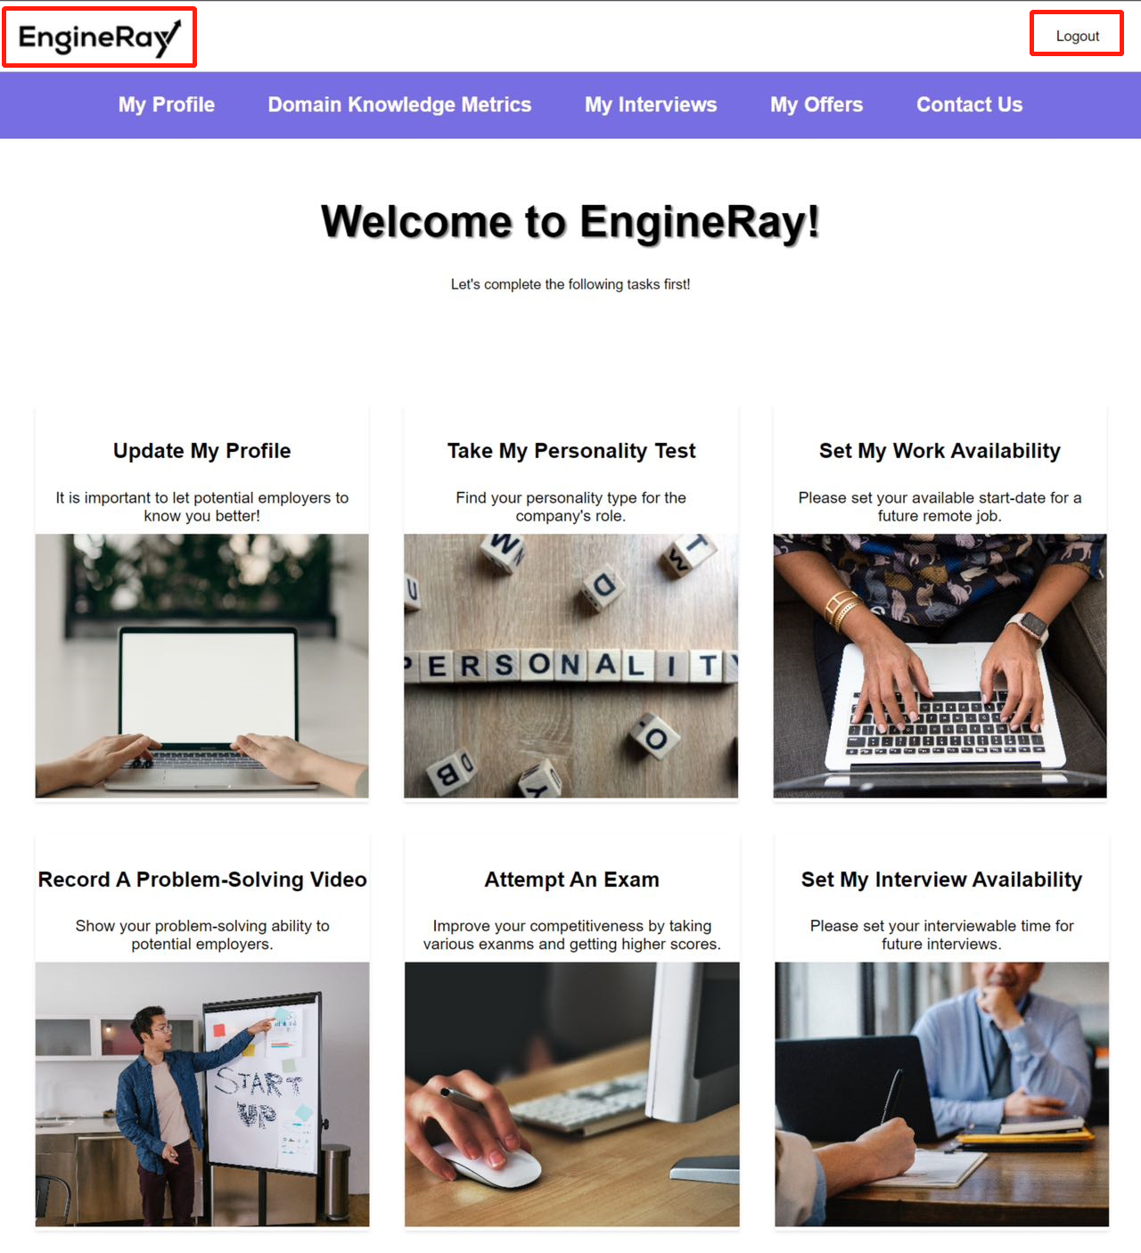

(Figure 1. Engineers’ **dashboard** page)

They will need to complete:

1. Update their personal profile.
2. Upload their profile image.
3. Upload a resume.
4. Set their work availability.
5. Complete a Personality Test
6. Set their interview availability.
7. Attempt at least 3 exams.
8. Record at least 2 problem-solving videos.
9. Attempt at least 3 mock interviews.

## Update their personal profile.

Engineer needs to click the “**Update My Profile**” card first to fill out their personal profile.

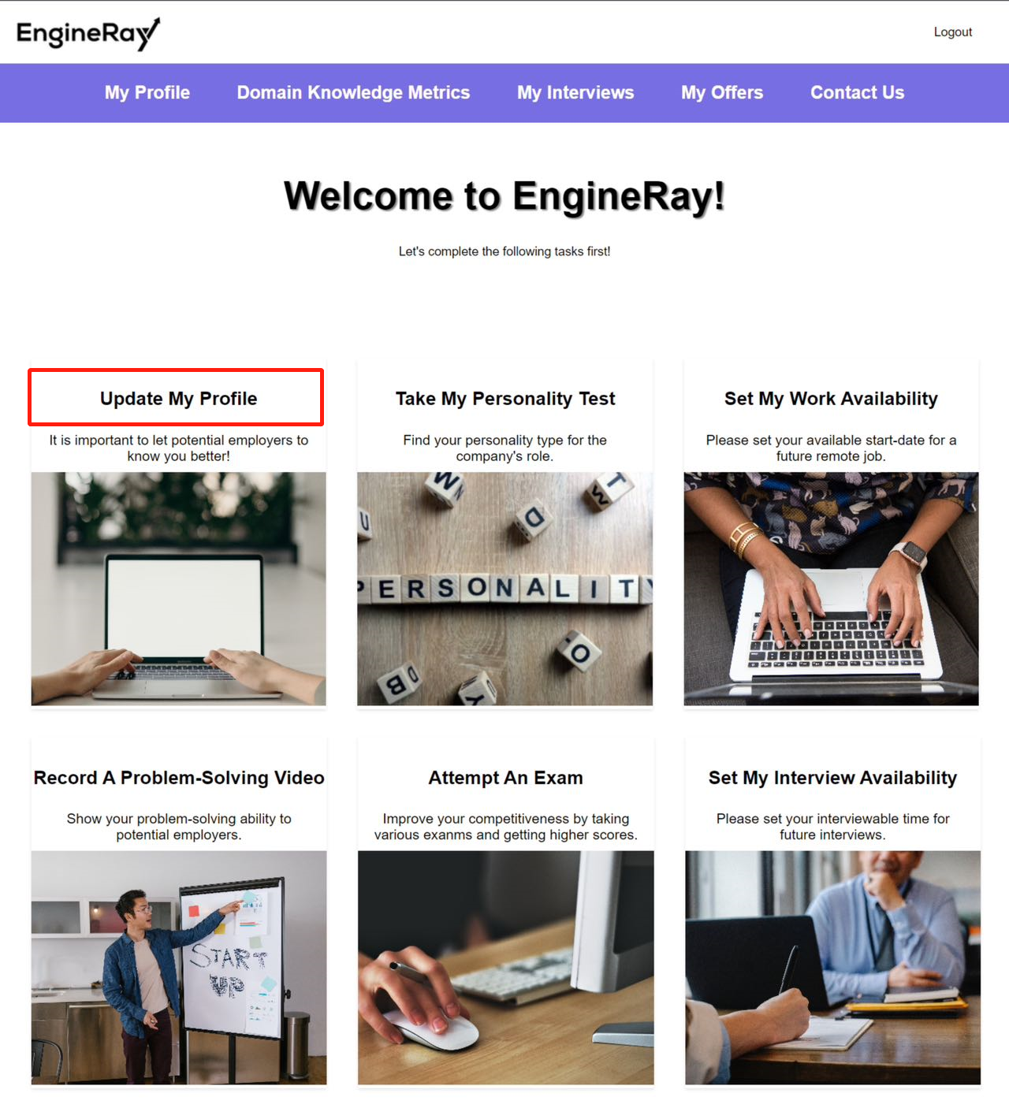

(Figure 2. Click “**Update My Profile**” card on the **dashboard** page to fill out personal profile)

Engineers need to fill in the blanks and select from the drop-down box of “*country*”, “*occupation*”, and “*skills*” fields then click the “**Update**” button to submit. All fields are required.

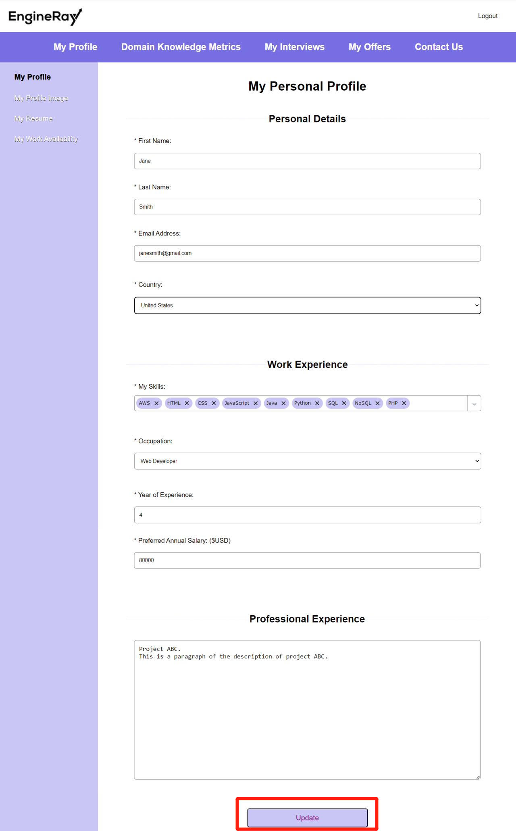

(Figure 3. Personal profile sample)

Error messages will be displayed in red under the field which is empty/not selected.

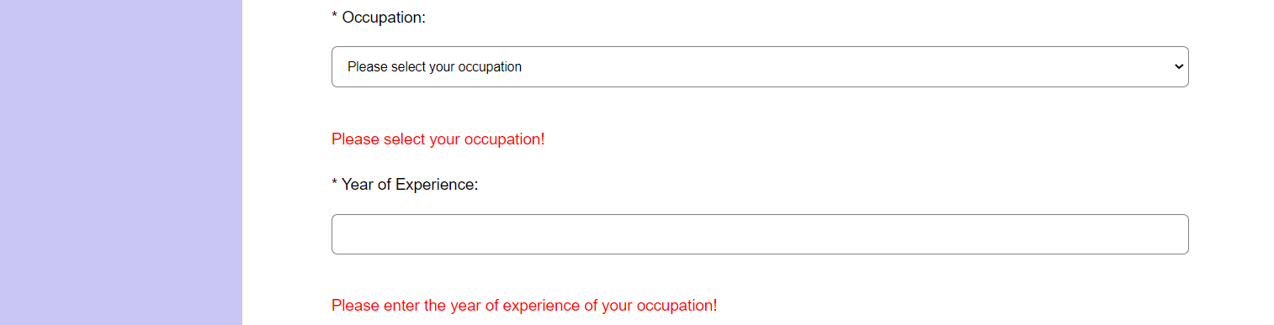

(Figure 4. Error message sample)

When it has been successfully submitted, engineers will be redirected to “**My Profile**” page automatically, which shows all the information that they have just provided.

They can click the “**My Profile**” button in the top navigation bar to view their profiles.

Whenever they want to make some changes to their profile, they can click the “**Update My Profile**” button at the bottom of the “**My Profile**” page.

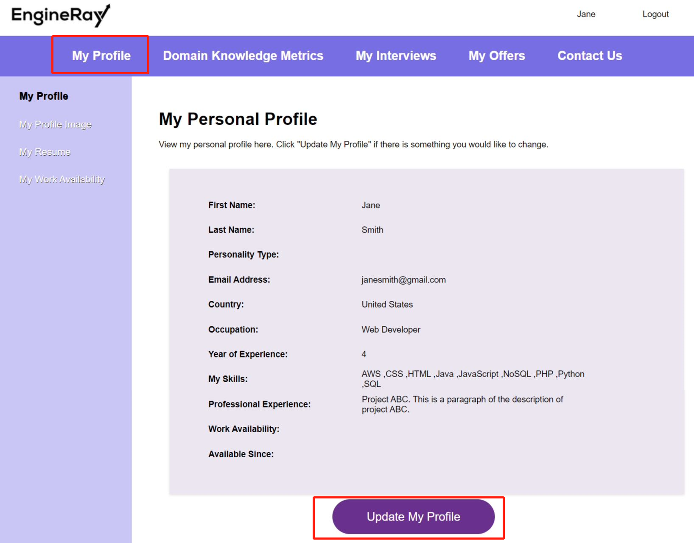

(Figure 5. “**My Profile**” page sample)

## Upload their profile image.

After the “**My Profile**” page has been completed, engineers need to upload their profile image as well. They will need to click on the “**My Profile Image**” button under the “**My Profile**” menu.

Click the “**Choose File**” button then select the image and click the “**Update**” button at the bottom of the page to upload a profile image.

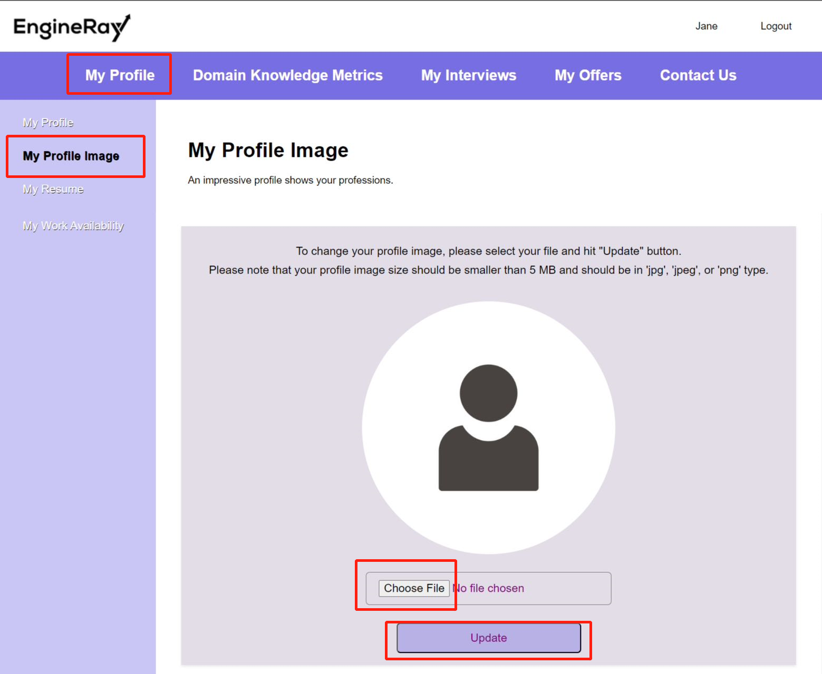

(Figure 6. Default “**My Profile Image**” page)

The default profile image will be changed to the engineer’s profile image once it has been successfully uploaded.

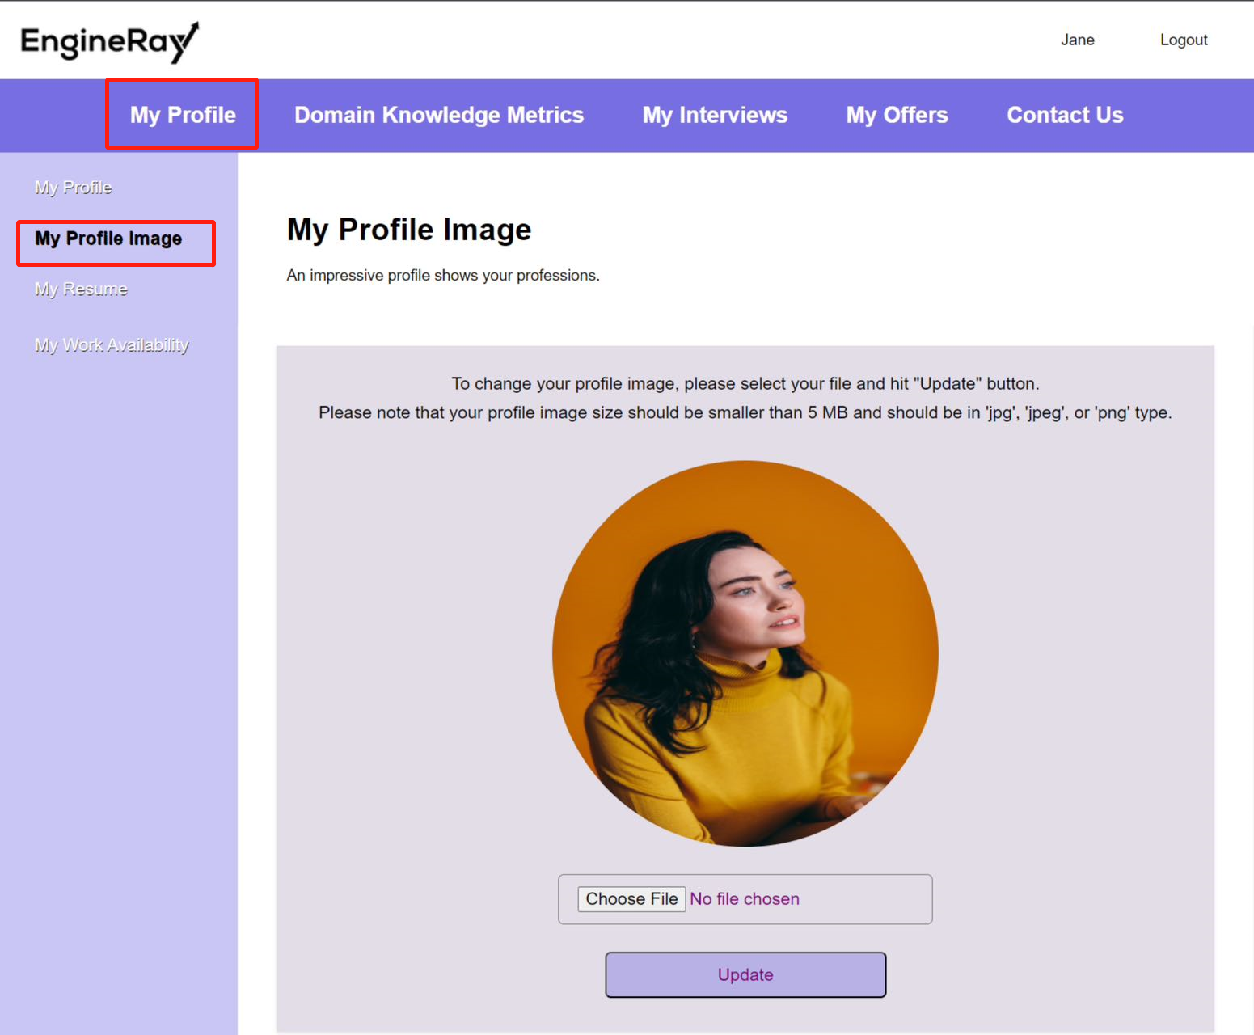

(Figure 7. Upload profile image in the “**My Profile Image**” page sample)

## Upload a resume.

Engineers also need to upload their resumes in the “**My Resume**” page under the “**My Profile**” menu. Similar to uploading a profile image, engineers need to select their resume files by clicking the “**Choose File**” button and then hit the “**Upload**” button at the bottom.

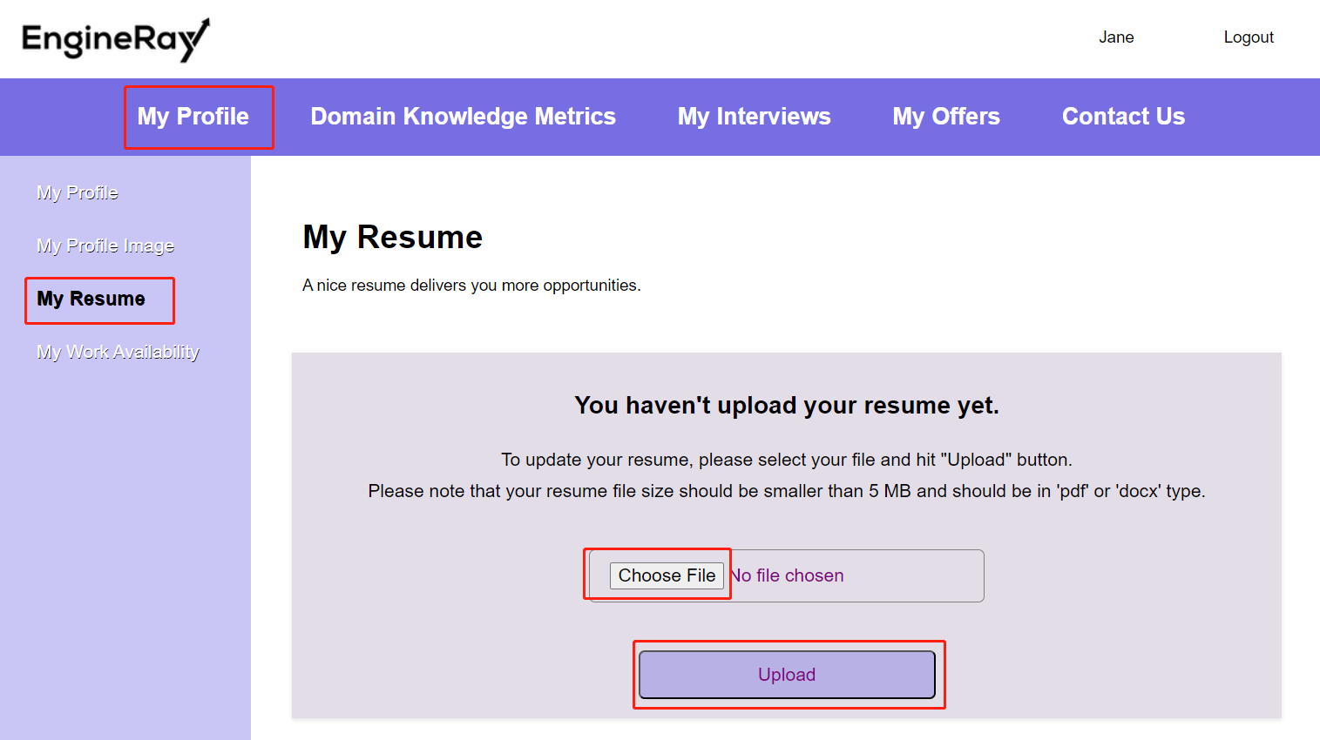

(Figure 8. Default “**My Resume**” page)

Once they have uploaded their resumes, they can download the resumes by clicking at this “**View My Resume**” button.

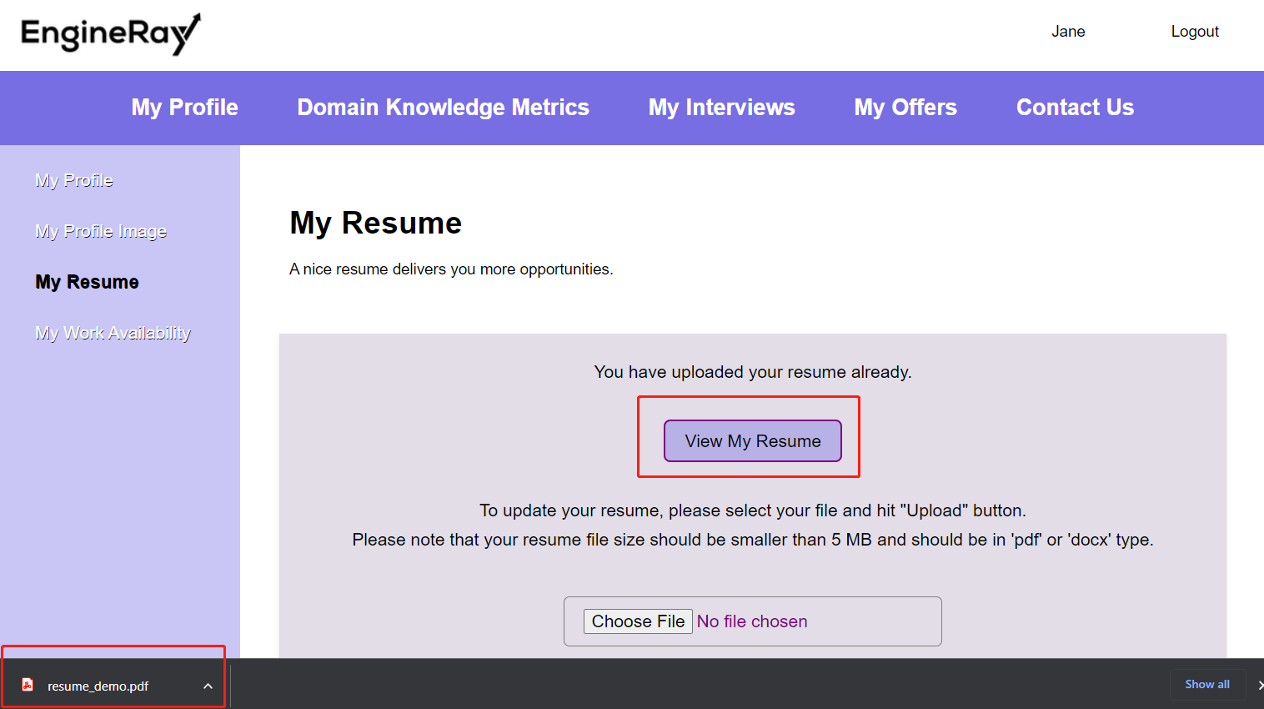

(Figure 9. View/Download the uploaded resume on “**My Resume**” page)

## Set their work availability.

Engineers can indicate their work availability on the “**My Work Availability**” page under the “**My Profile**” menu. They will need to choose either “**Ready to work**” or “**Unavailable for work**”. Clicking on the “**Set My Work Availability**” card on the **dashboard** page can also lead engineers to this page.

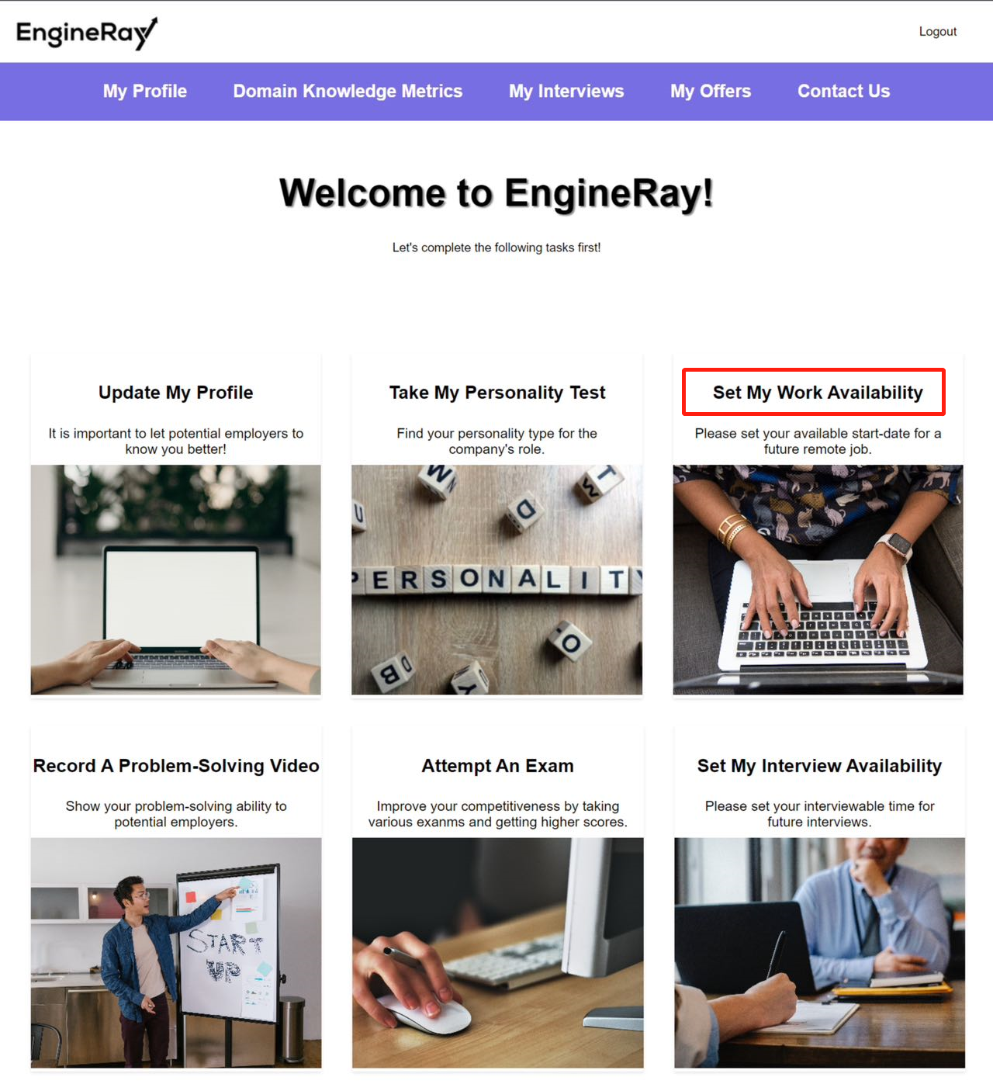

(Figure 10. Dashboard entrance for “**Set My Work Availability**” page)

-If “**Ready to work**” is selected, engineers also need to indicate the date that they can start with, then hit the “**Update My Work Availability**” button at the bottom.

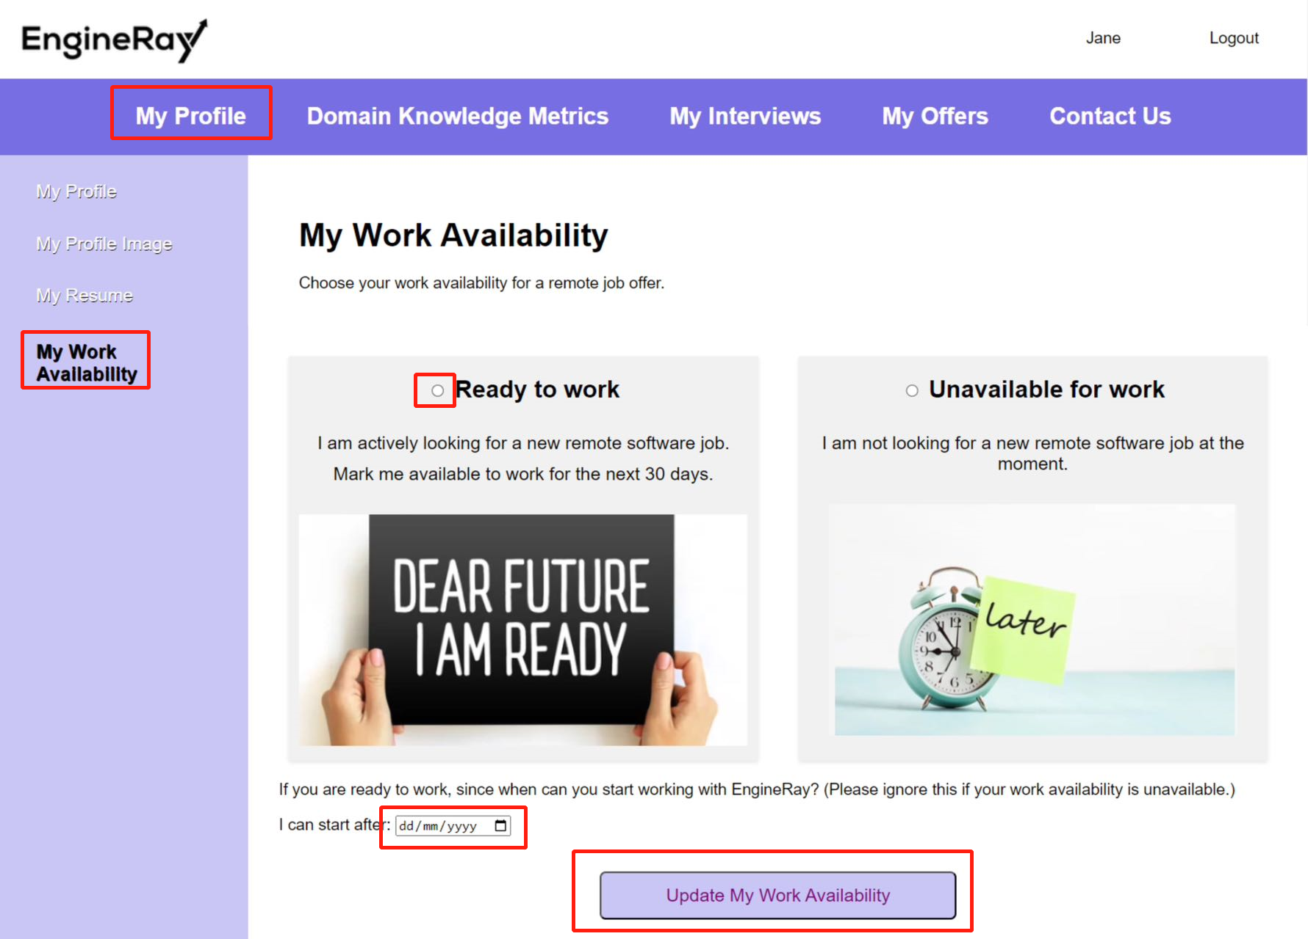

(Figure 11. Indicate work availability on the “**My Work Availability**” page)

If the start date is empty for a “**Ready to work**” status, an error message will be shown.

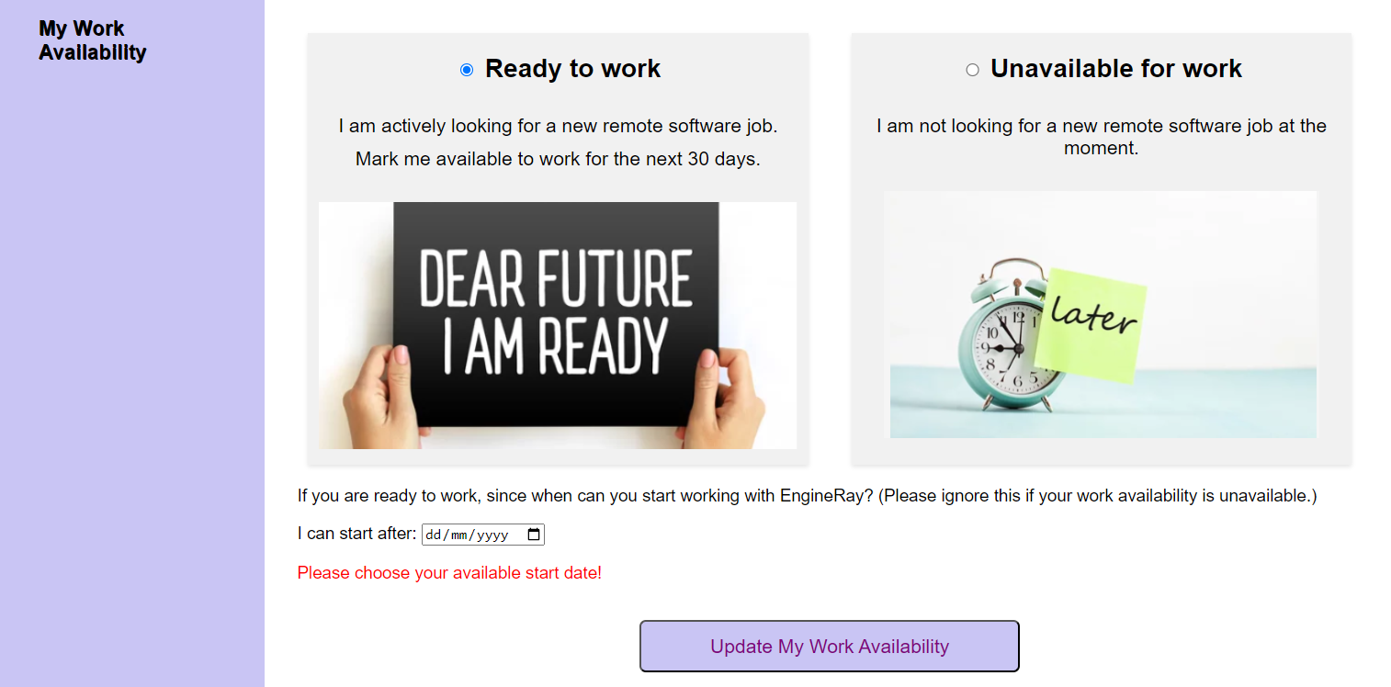

(Figure 12. Error message sample for “**My Work Availability**” page)

A confirmation message will be displayed if the work availability is successfully updated.

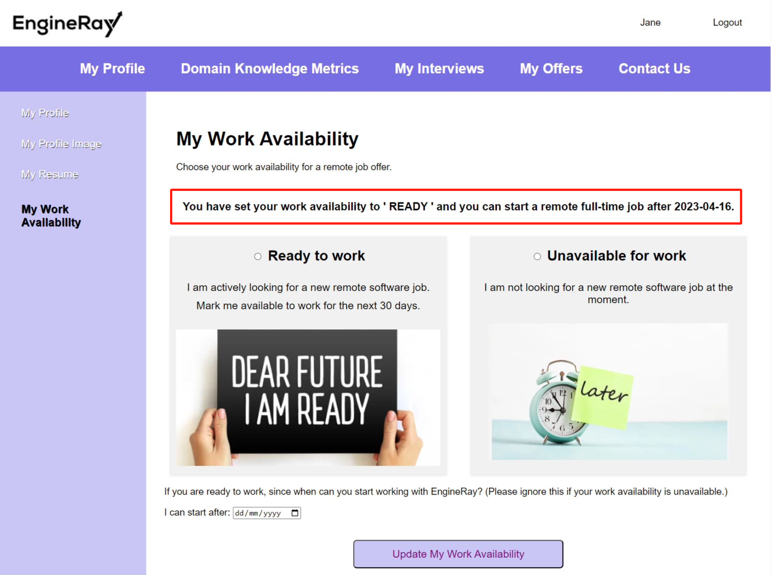

(Figure 13. Confirmation message for “**Ready to work**” on the “**My Work Availability**” page)

Engineers can also go to “**My Profile**” page to see the updated work availability:

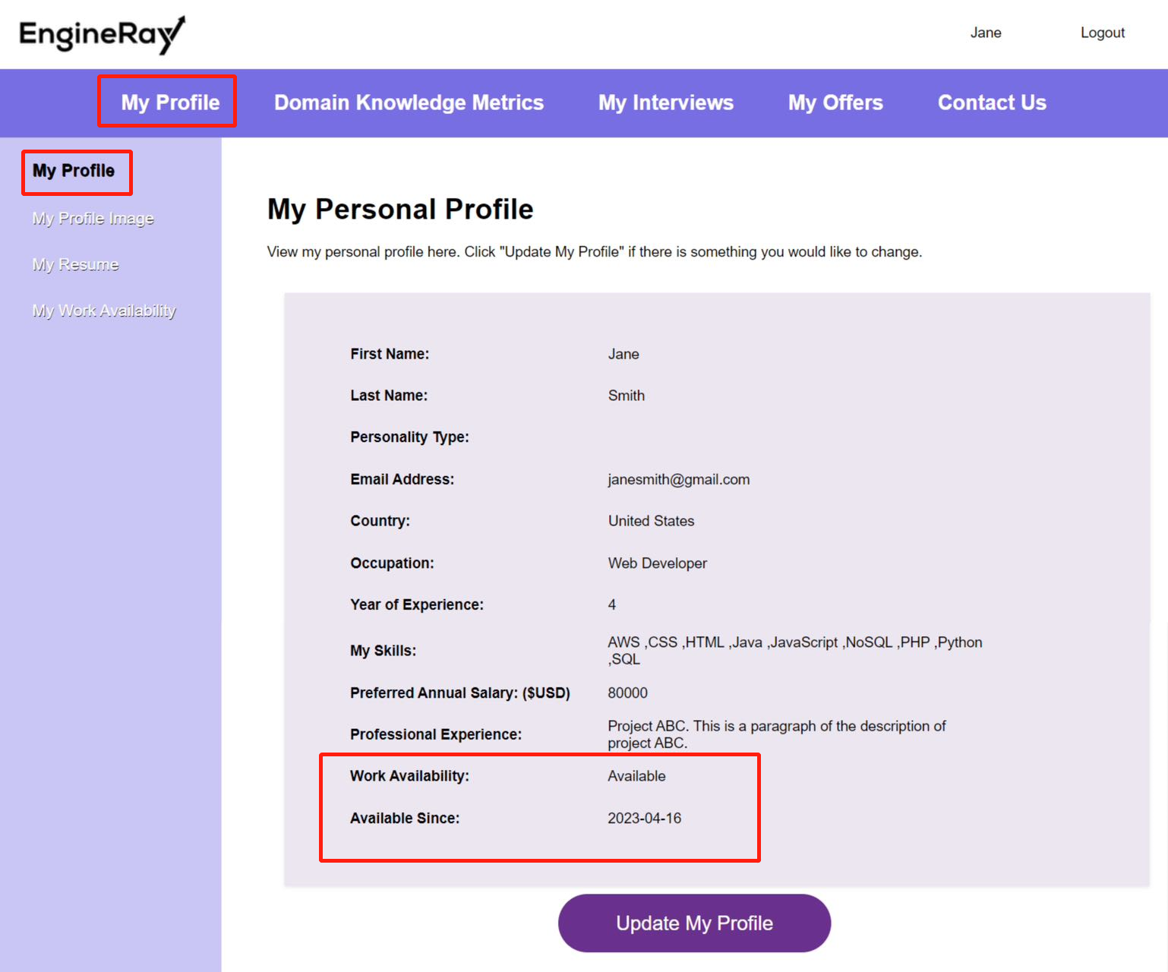

(Figure 14. Updated work availability in “**My Profile**” page sample)

-If “**Unavailable for work**” is selected, engineers can click the “**Update My Work Availability**” button straight away. A confirmation message will be displayed if the work availability is successfully updated.

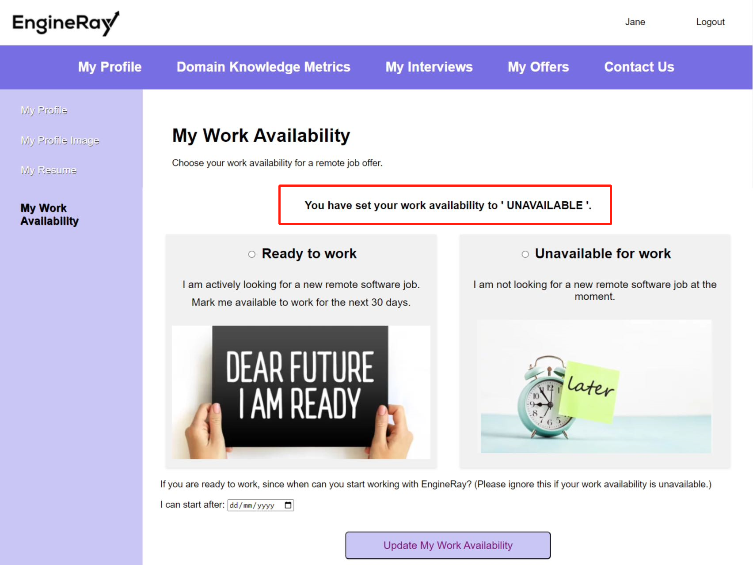

(Figure 15. Confirmation message for “**Unavailable for work**” on the “**My Work Availability**” page)

Engineers can also go to “**My Profile**” page to see the updated work availability:

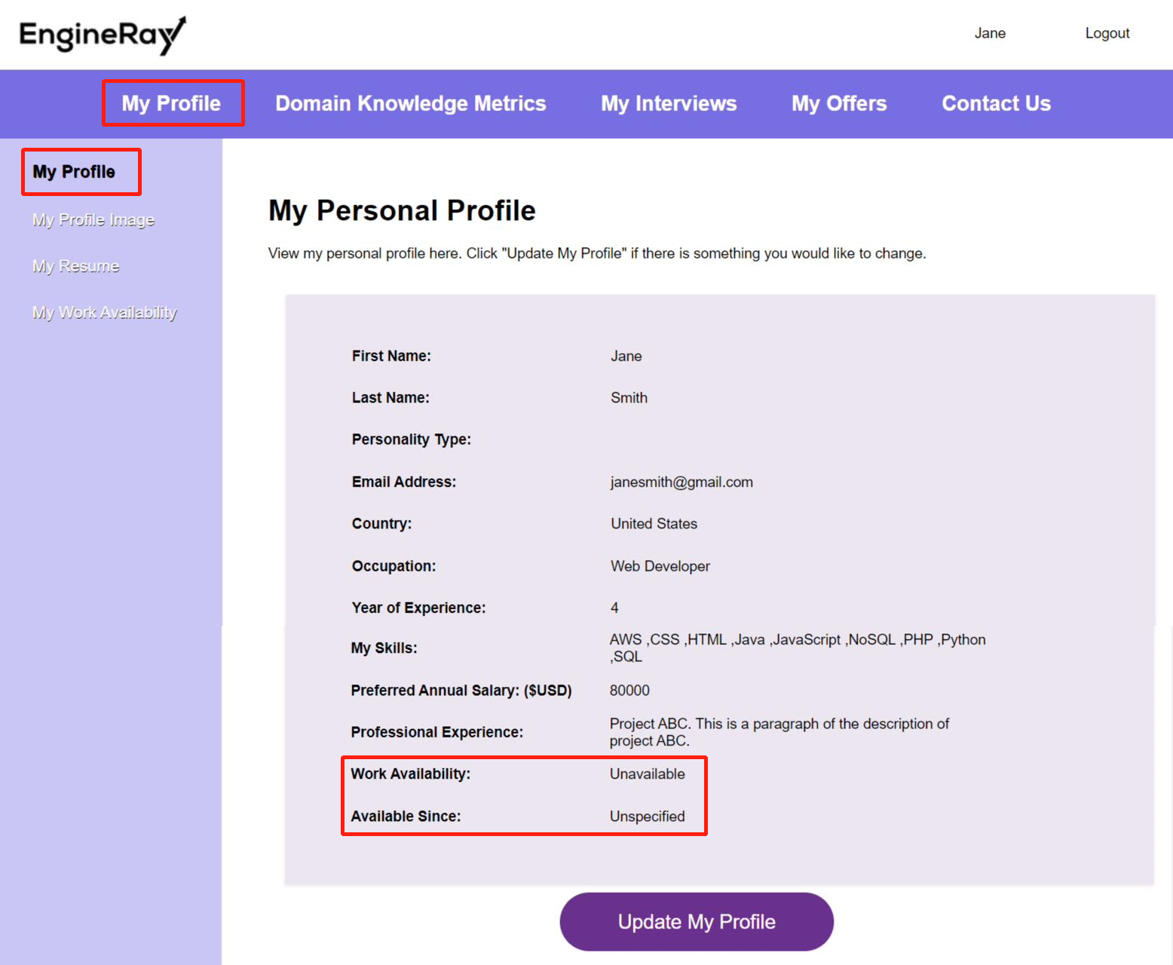

(Figure 16. Updated work availability in “**My Profile**” page sample)

## Complete a Personality Test

Engineers need to complete a personality test so that companies can learn more about their personalities. The test can also be attempted once, therefore, the only entrance for the page is on the **dashboard** by clicking on the “**Take My Personality Test**” card.

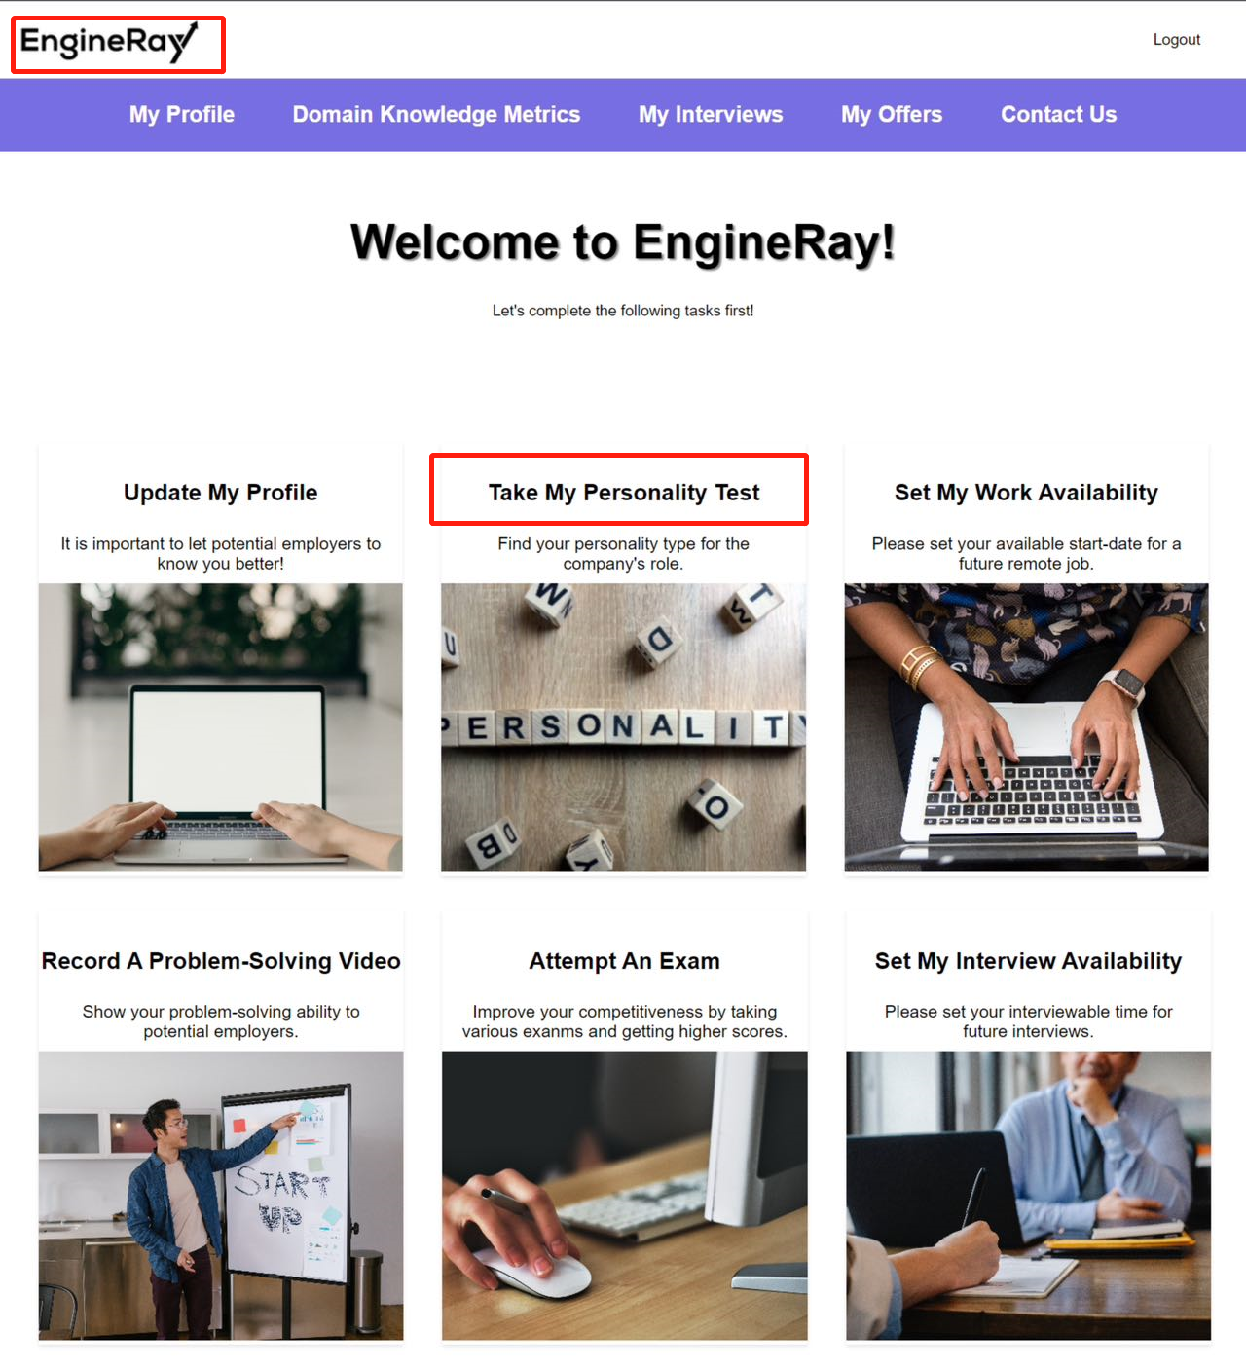

(Figure 17. **Dashboard** entrance for “**My Personality Test**” page)

Engineers can start the personality test by clicking on the “**Test Now**” button, which will redirect them to another Google Forms page.

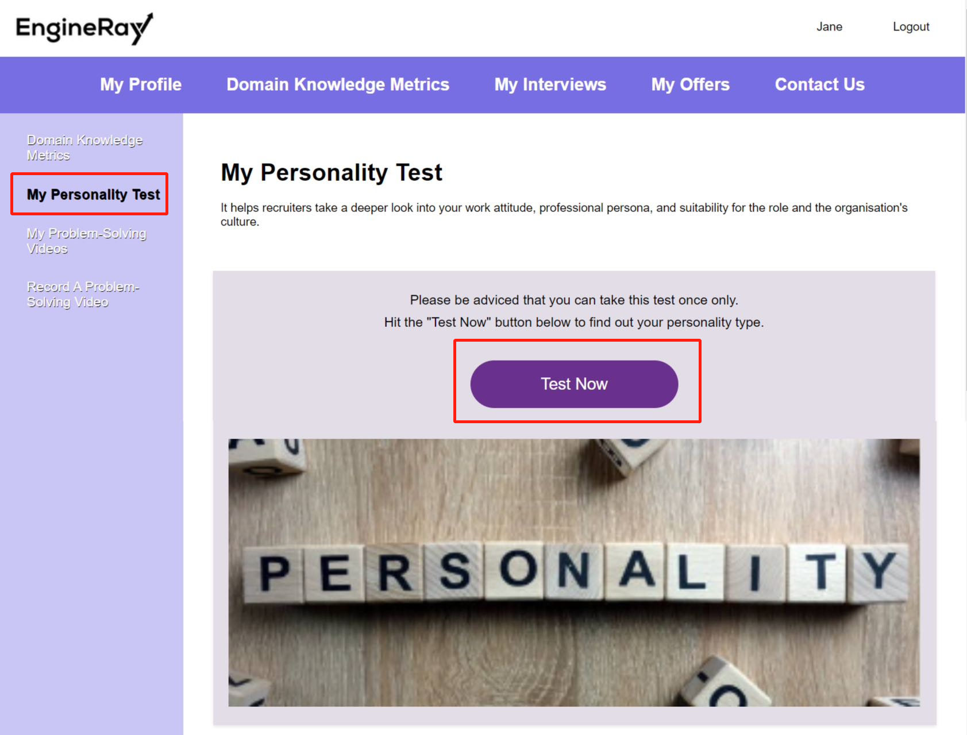

(Figure 18. “**My Personality Test**” page)

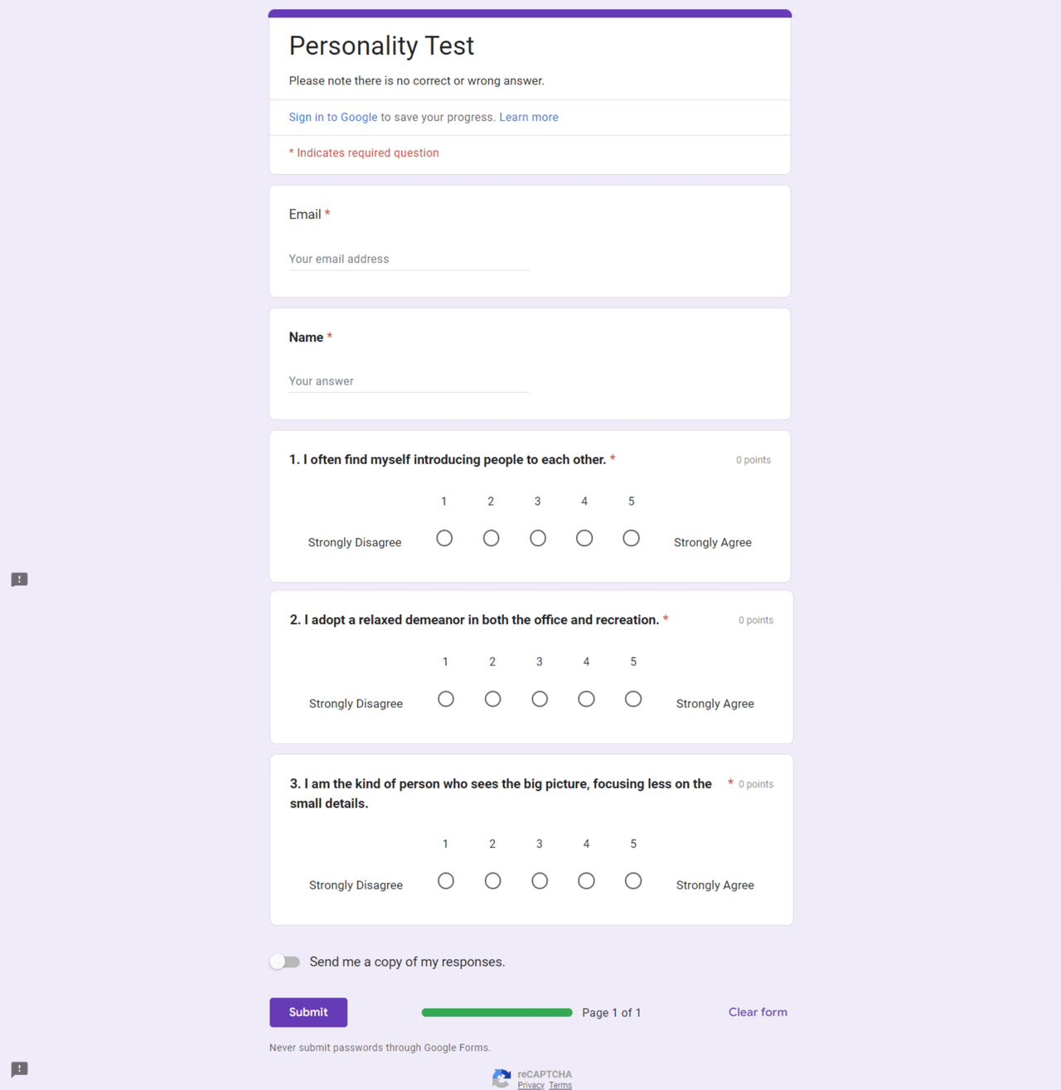

(Figure 19. Personality Test Sample on Google Forms)

## Set their interview availability.

Engineers can go to “**My Interview Availability**” page under the “**My Interviews**” menu to indicate there are available for either mock interviews or interviews.

Clicking on the “**Set My Interview Availability**” card on the **dashboard** page can also lead engineers to this page.

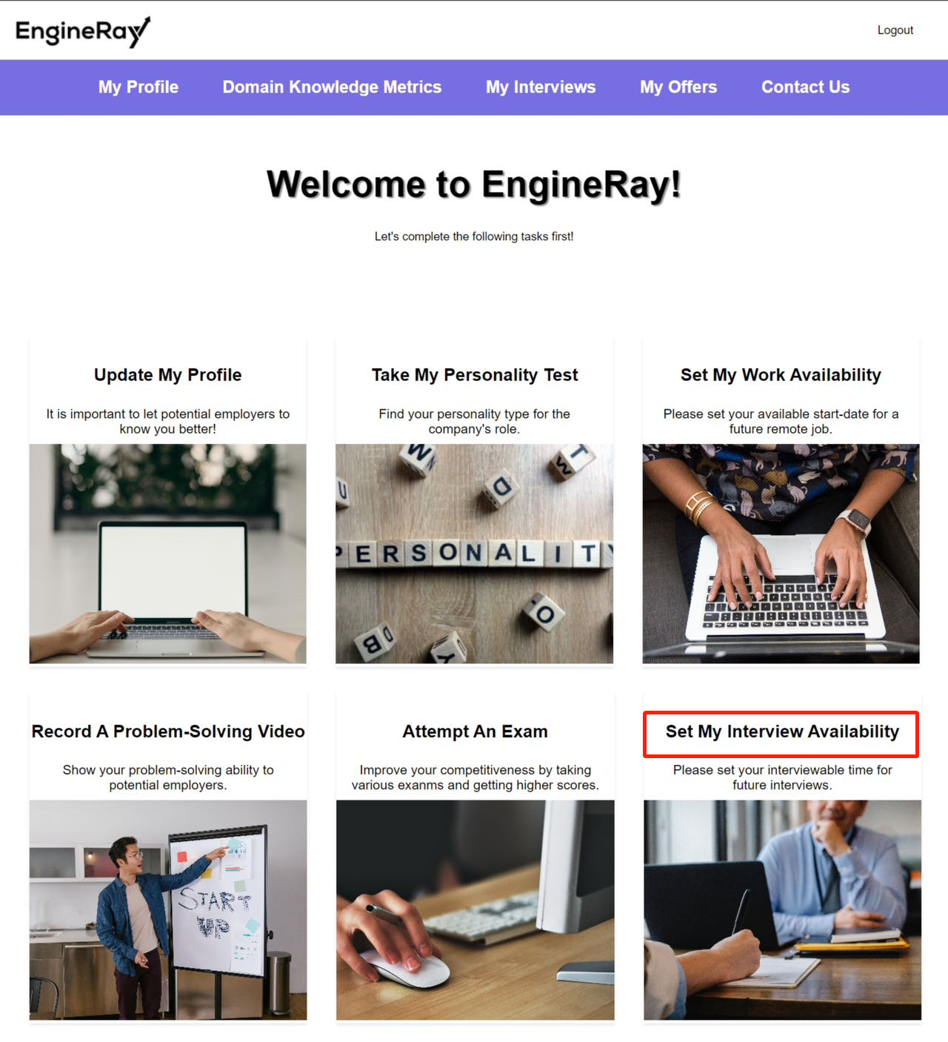

(Figure 20. Dashboard entrance for “**Set My Interview Availability**” page)

They can choose the availability then hit the “**Update My Interview Availability**” button. If they selected “**I am available for any interviews**”, they will also need to select a date and time for a possible interview meeting.

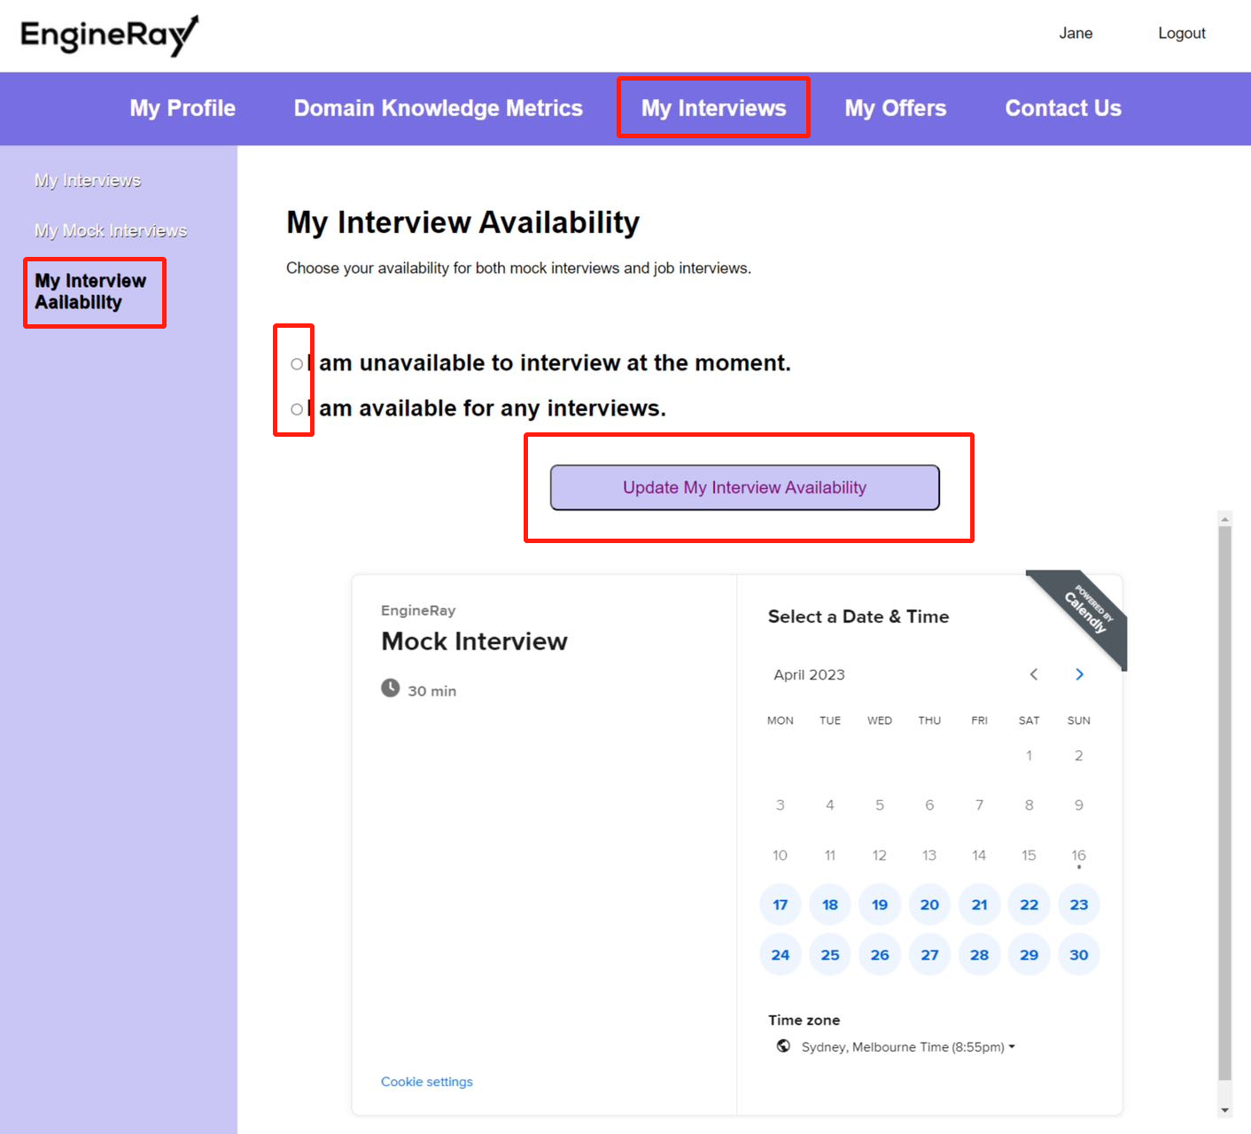

(Figure 21. “**My Interview Availability**” Page)

Engineers need to select a date in the calendar, then a time and click the “**Confirm**” button to continue.

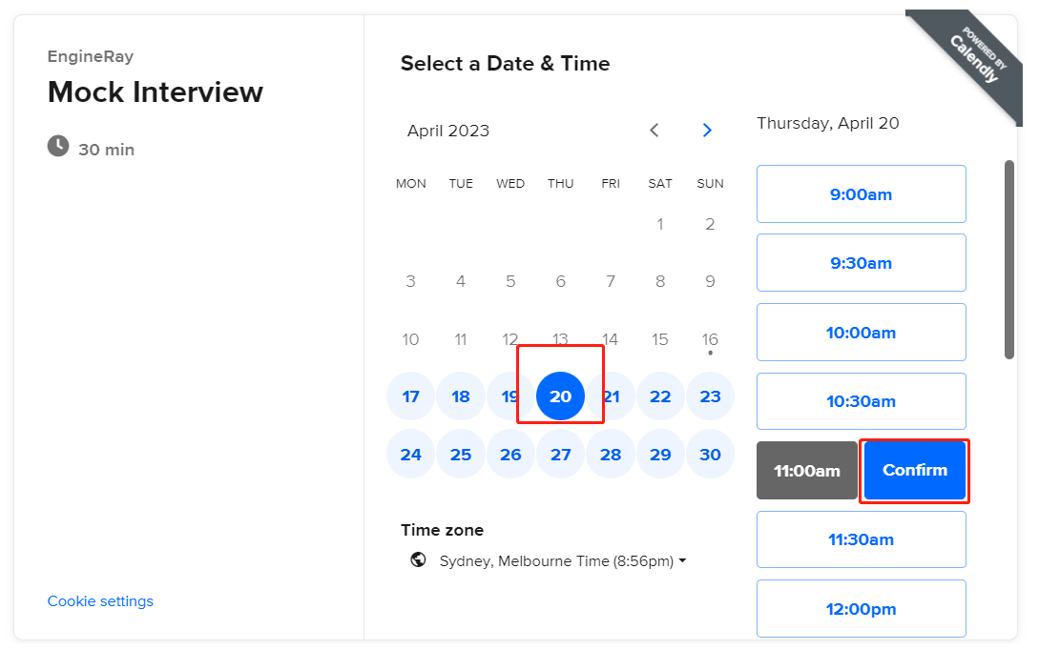

(Figure 22. Schedule a sample interview meeting on “**My Interview Availability**” Page Step 1)

Fill out the “*Name \**” and “*Email \**” area then hit the “**Schedule Event**” button.

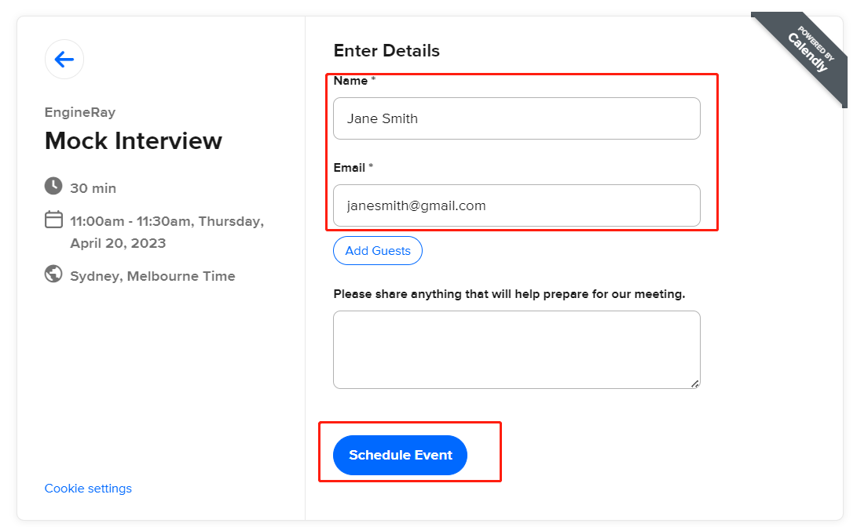

(Figure 23. Schedule a sample interview meeting on “**My Interview Availability**” Page Step 2)

If successfully scheduled, a confirmation message will be displayed.

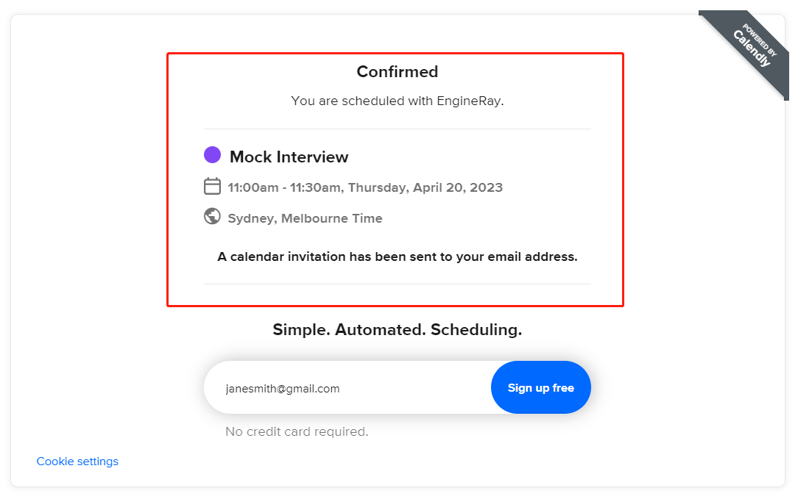

(Figure 24. Successfully scheduled a sample interview meeting on “**My Interview Availability**” Page)

## Attempt at least 3 exams.

There are various exams for engineers to attempt to improve their domain knowledge metrics. Engineers can find them on the “**Domain Knowledge Metrics**” page under the “**Domain Knowledge Metrics**” menu.

Clicking on the “**Attempt An Exam**” card on the **dashboard** page can also lead engineers to this page.

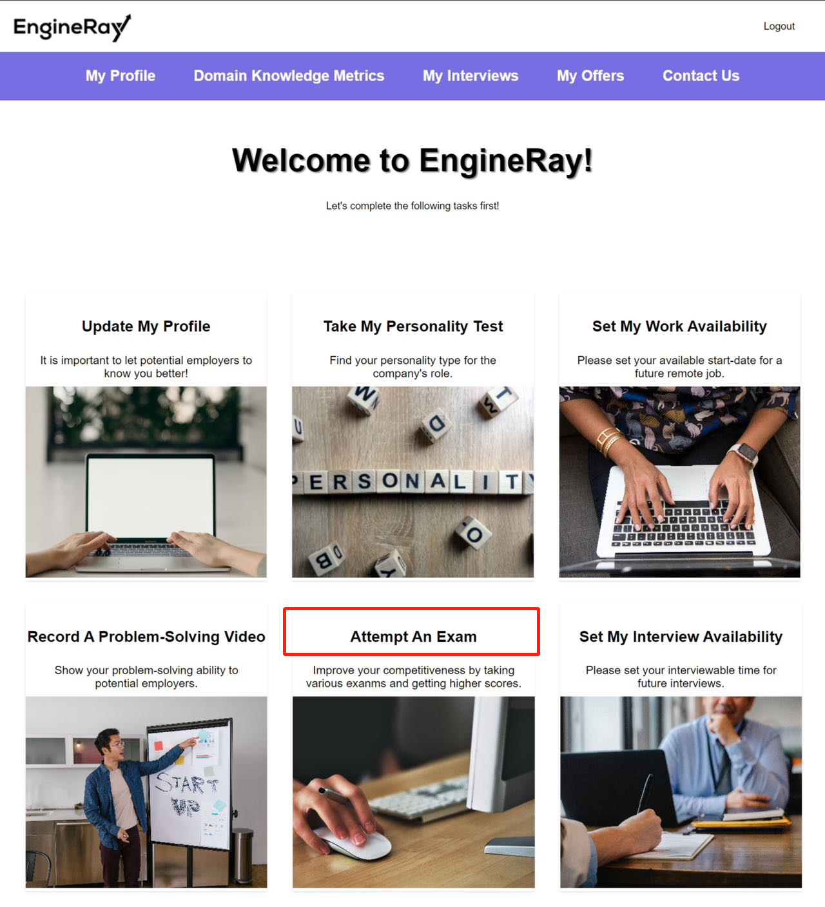

(Figure 25. **Dashboard** entrance for “**Domain Knowledge Metrics**” page)

If an engineer has not attempted any assessment yet, a message of “**Ah-Oh! You have not taken any exams yet.**” will be shown to the engineer.

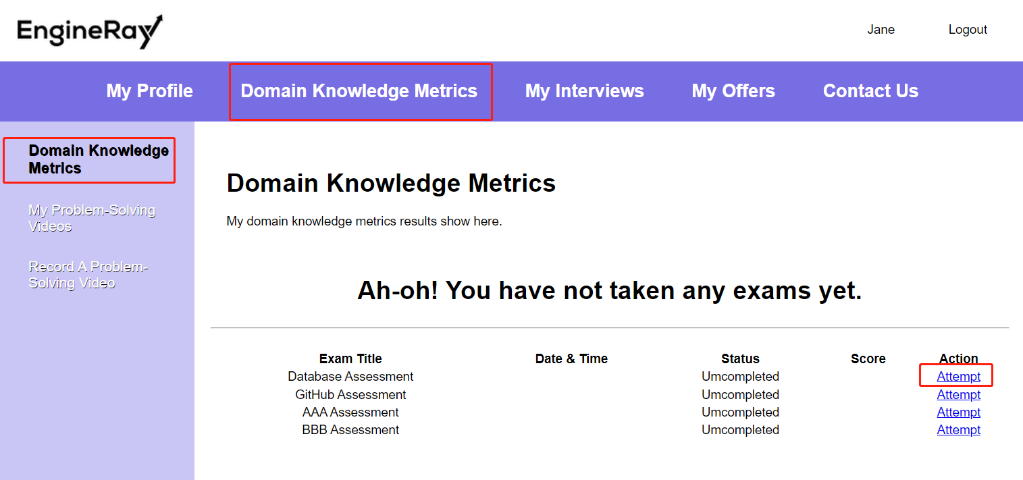

(Figure 26. Default “**Domain Knowledge Metrics**” page)

Engineers can click on the “**Attempt**” link to attempt a specific assessment. They will be redirected to an associated Google Forms webpage to fill out the assessment.

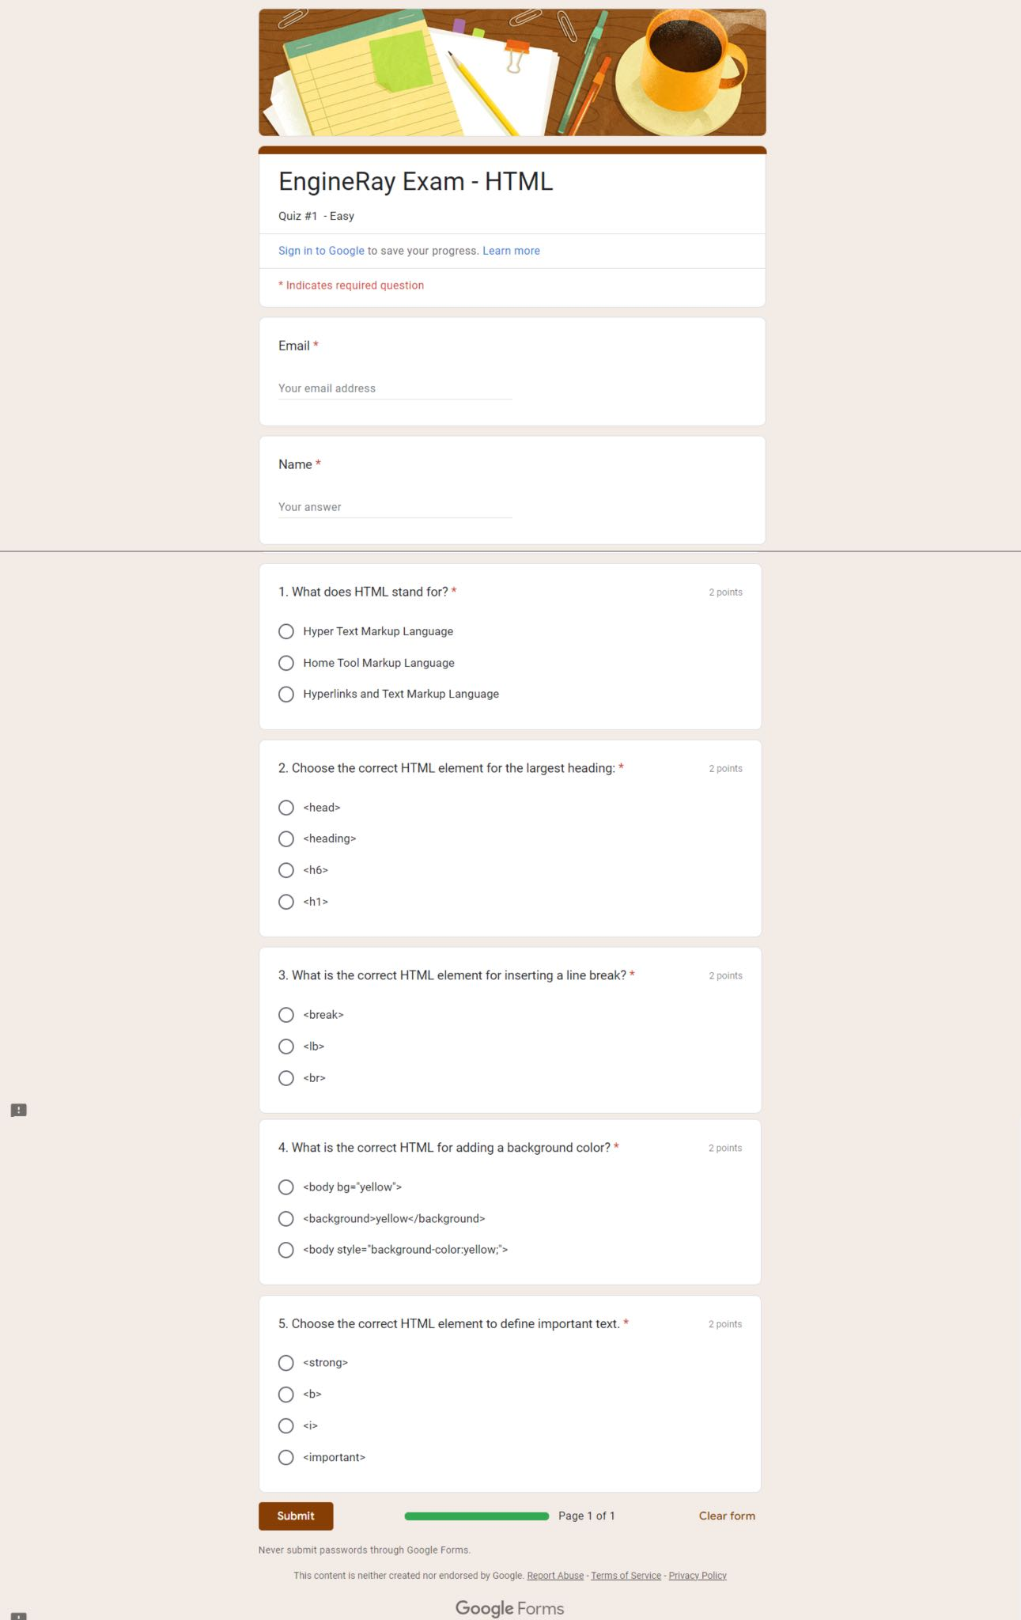

(Figure 27. A sample assessment on Google Forms)

If an engineer has taken some exams, the scores of them will be shown individually. The engineer can view the exam results by clicking on “**View**” button, or retake the assessment by hitting on the “**Retake**” button.

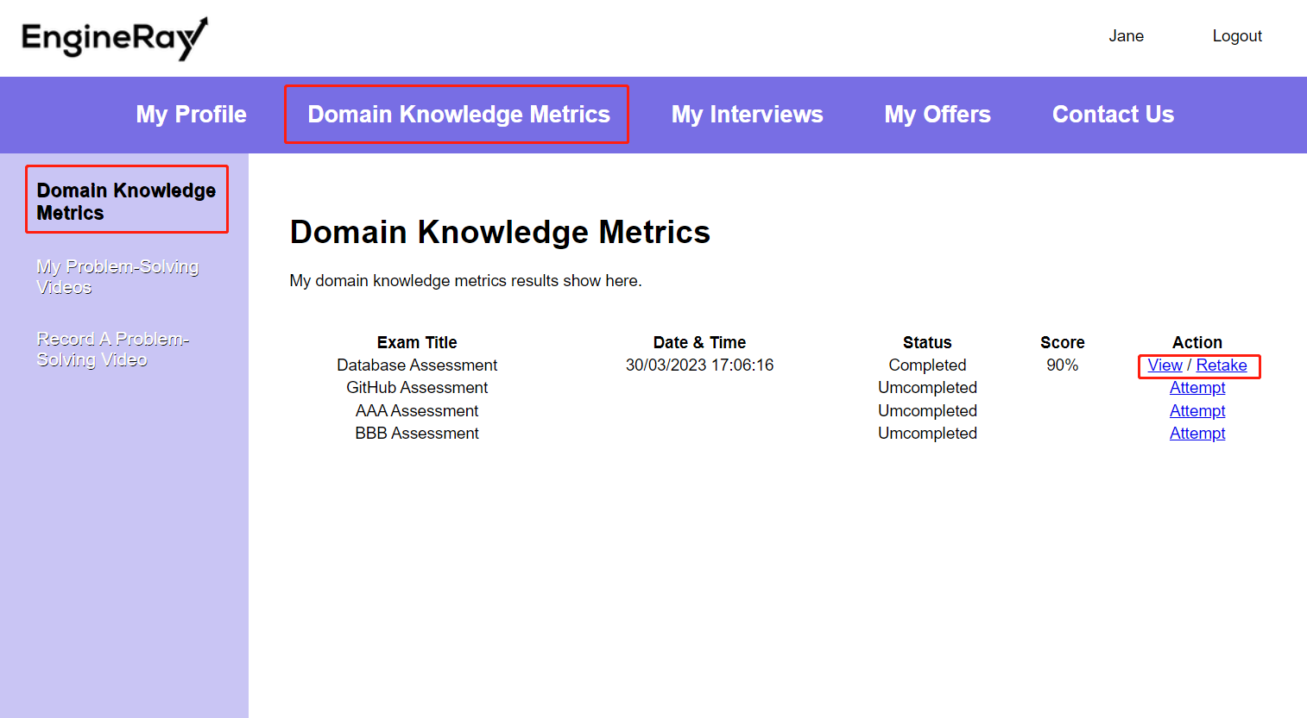

(Figure 28. Sample of attempted exams on “**Domain Knowledge Metrics**” page)

## Record at least 2 problem-solving videos.

The “**My Problem-Solving Videos**” page under the “**Domain Knowledge Metrics**” displays all the problem-solving videos that the engineer has recorded. If there are no videos recorded, a message of “**Ah-Oh! You don’t have any problem-solving videos yet.**”

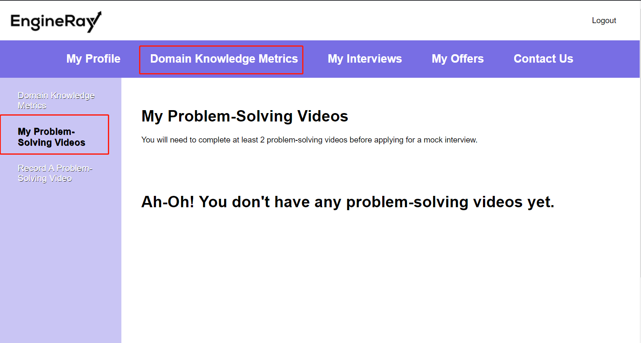

(Figure 29. Default “**My Problem-Solving Videos**” page)

Engineers will need to go to the “**Record A Problem-Solving Video**” page under the “**Domain Knowledge Metrics**” menu to record a problem-solving video. They will be redirected to another page to start recording once they have clicked on the “**Start**” button.

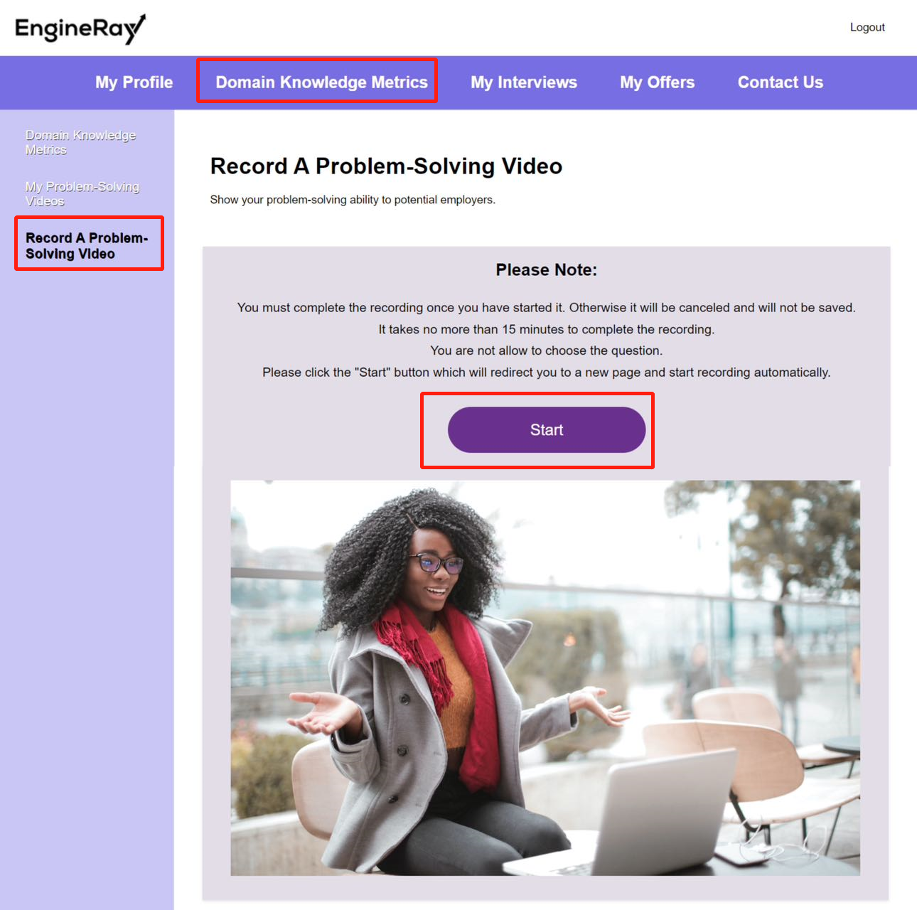

(Figure 30. Default “**Record A Problem-Solving Video**” page)

Clicking on the “**Record A Problem-Solving Video**” card on the **dashboard** page can also lead engineers to this page.

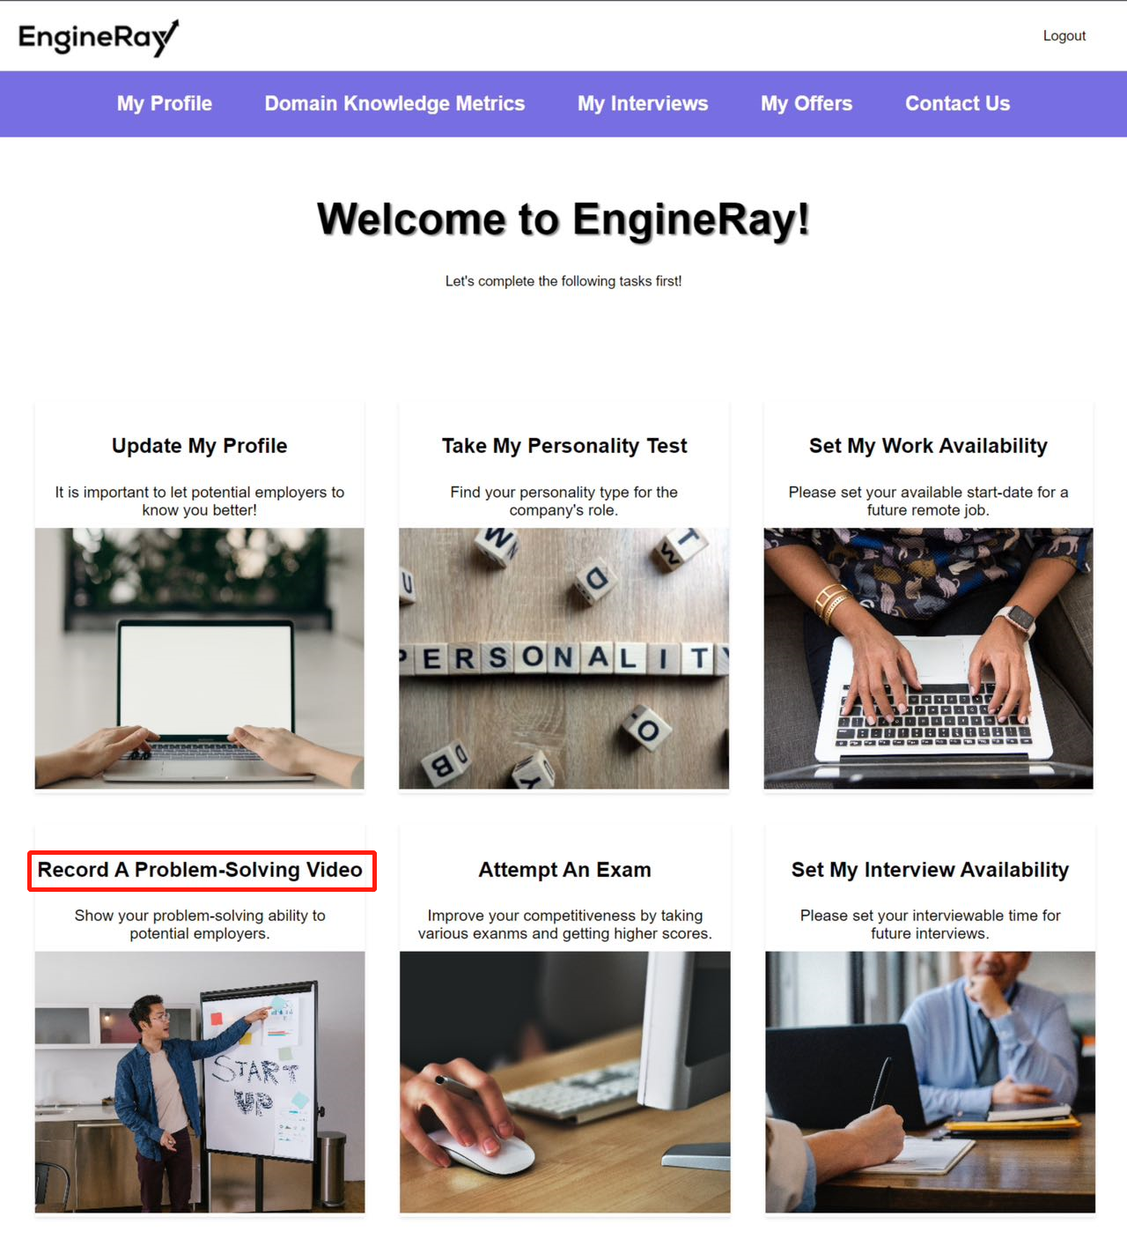

(Figure 31. **Dashboard** entrance for “**Record A Problem-Solving Video**” page)

Once the engineer has recorded some problem-solving videos, it will list out all the videos that the engineer has recorded. Engineers can play videos on the page directly.

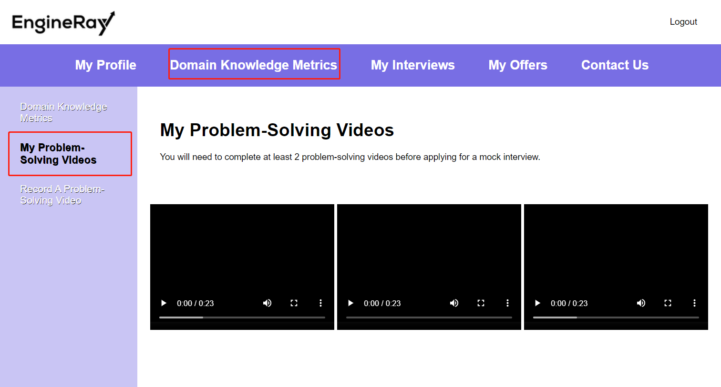

(Figure 32. “**My Problem-Solving Videos**” page with videos recorded)

## Attempt at least 3 mock interviews.

Engineers can find out their mock interviews in the “**My Mock Interviews**” page under the “**My Interviews**” menu.

If an engineer has not scheduled any mock interview yet, a message of “**Ah-Oh! You don’t have any mock interview records yet.**” will be shown to the engineer.

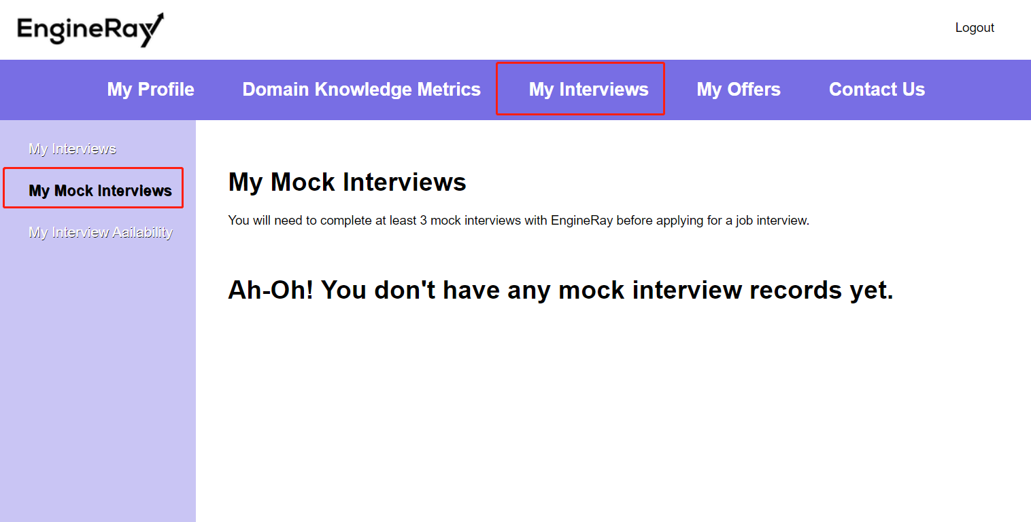

(Figure 33. Default “**My Mock Interviews**” page)

Once the mock interview has been scheduled, the relevant details will be displayed in the “**My Mock Interviews**” page. The engineer can access the interview meeting via the “**Zoom Meeting**” link provided.

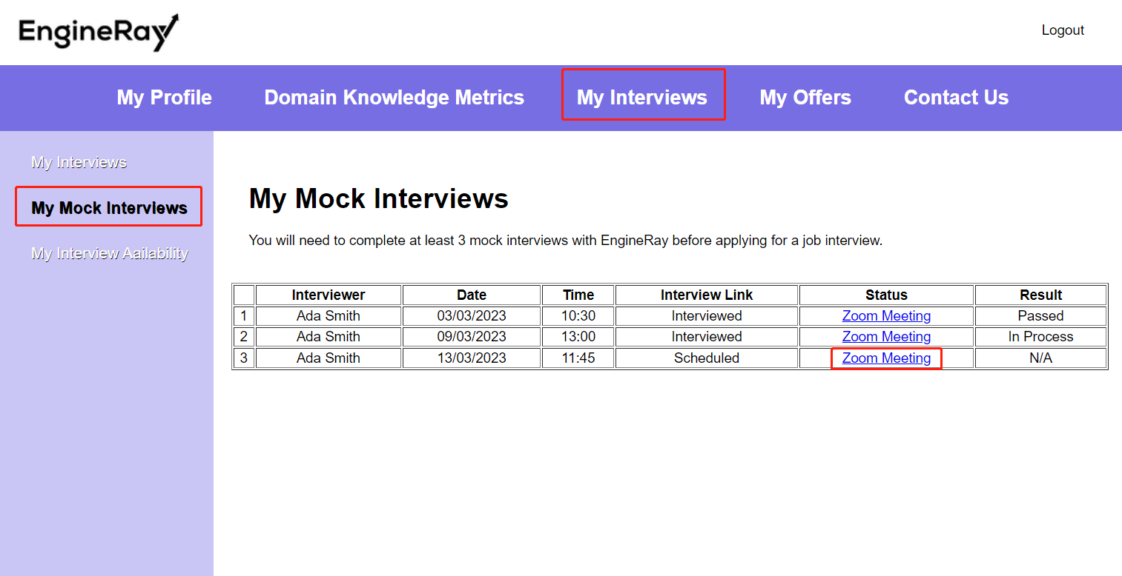

(Figure 34. “**My Mock Interviews**” page with record samples)

## After The Preparation

Once engineers have completed all the preparation mentioned above, they will receive official interview invitations from the companies.

They will need to do:

1. Attend the interviews and leave feedback for the interview process.
2. Accept/Reject the offer received from the company.
3. Sign the contract digitally.
4. Receive payment from *EngineRay*

## Attend the interviews and leave feedback for the interview process.

Engineers can find their interview records in the “**My Interviews**” page under the “**My Interviews**” menu. It shows a message of “**Ah-Oh! You don’t have any interview records yet**” by default.

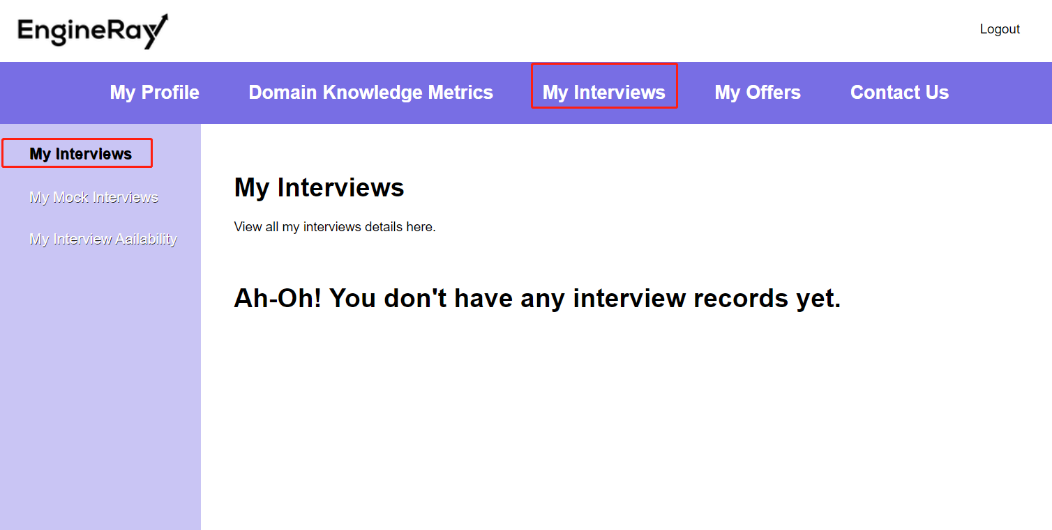

(Figure 35. Default “**My Interviews**” page)

Once the engineer has received interview invitations, he can see the details of interview in the “**My Interviews**” page, and the interview link is provided so the engineer can access the meeting directly from this page.

The engineer can click on the “**Leave A Feedback**” button to leave feedback of the interview process after the interview was conducted. If the interview has not been conducted yet, the “**Result**” will be “**Not Available**” and the “**Leave A Feedback**” button is disabled.

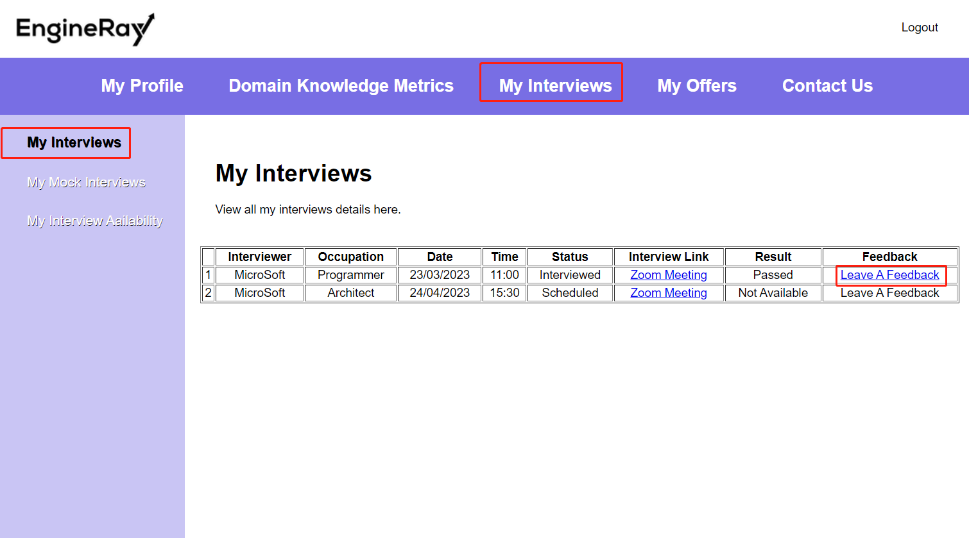

(Figure 36. “**My Interviews**” page with interview records)

## Accept/Reject the offer received from the company.

Engineers can find their offer history in the “**My Offers**” page under the “**My Offers**” menu. It shows a message of “**Ah-Oh! You have not received any offer yet**” by default.

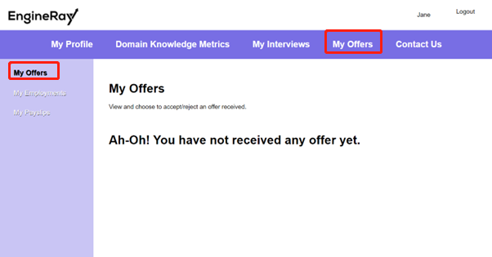

(Figure 37. Default “**My Offers**” page)

When the engineer receives an offer from the company after the interview was done and the company accepted him, the engineer can either accept or reject the offer by choosing “**Accept**” or “**Reject**” from the drop-down menu and click “**Confirm**” button.

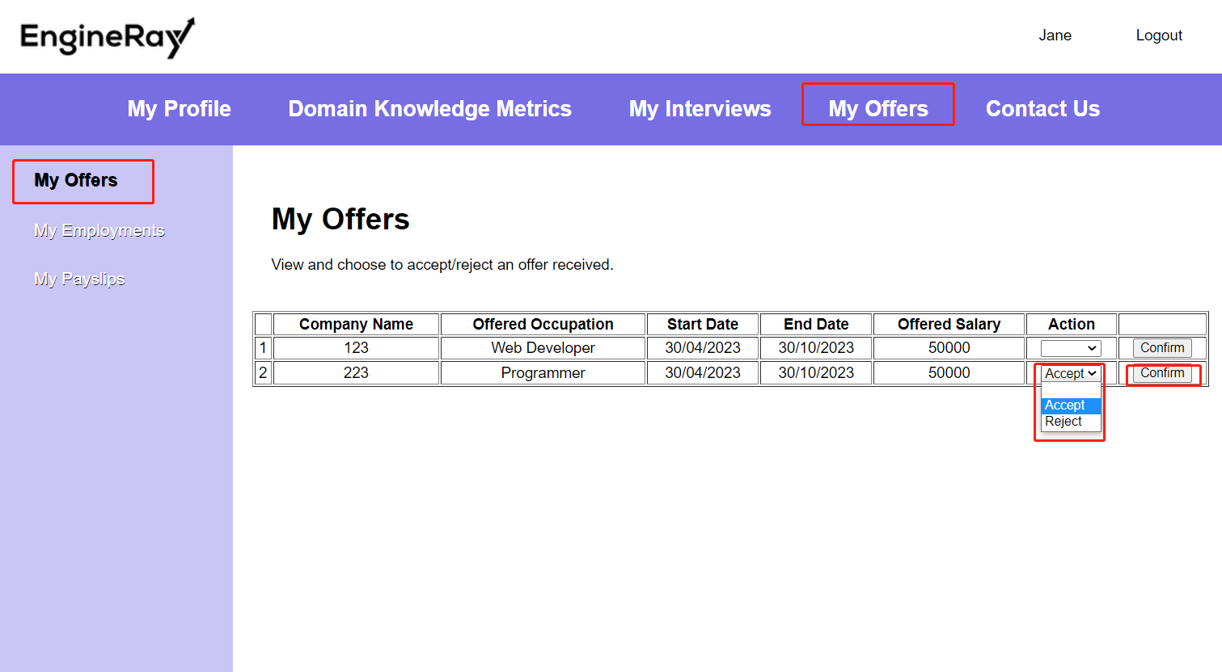

(Figure 38. Engineer accepts or rejects an offer in the “**My Offers**” page)

## Sign the contract digitally.

Once the engineer has accepted the offer, they will need to sign the contract digitally as well. They can find the contracts in the “**My Employments**” page under the “**My Offers**” menu. It shows a message of “**Ah-Oh! You don’t have any employment yet**” by default for every new user.

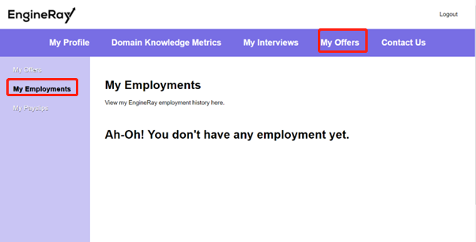

(Figure 39. Default “**My Employments**” page)

When the employment history and contract is available, engineers need to sign the contract by clicking on the link of “**Contract.pdf**”. This will redirect them to another page to sign the contract digitally via DocuSign API.

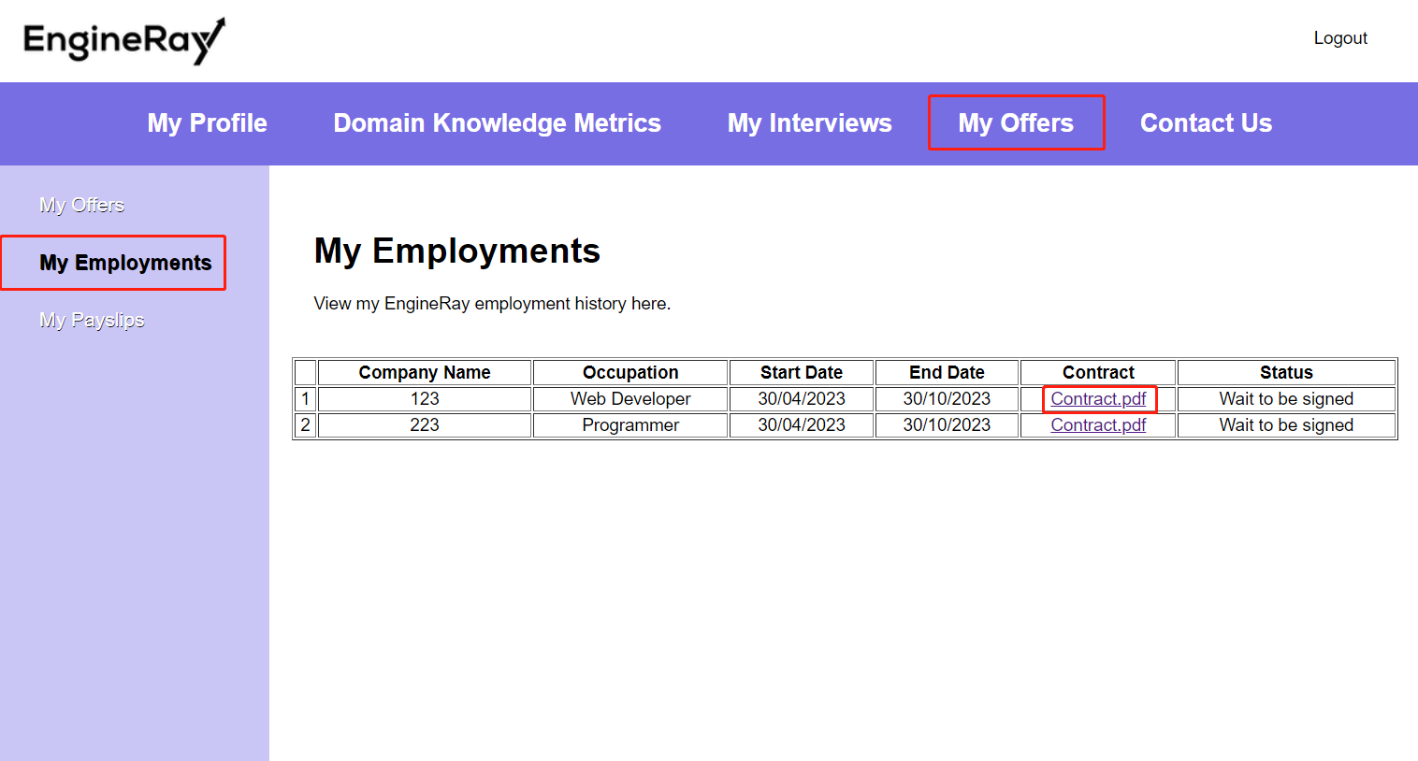

(Figure 40. Access the contract in the “**My Employments**” page)

## Receive payment from *EngineRay*

Engineers will receive their payments from *EngineRay* after they are hired. They can find the pay slips in the “**My Payslips**” page under the “**My Offers**” menu. It shows a message of “**Ah-Oh! You don’t have any payslip yet**” by default.

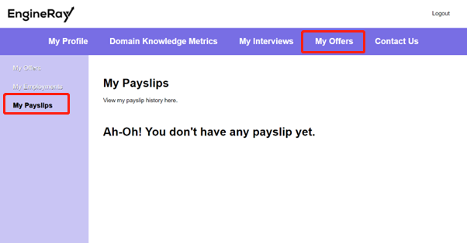

(Figure 41. Default “**My Payslips**” page)

When they have received the payment from *EngineRay*, they can view the details of that payment, and download the file by clicking on the “**Pay slip.pdf**” link.

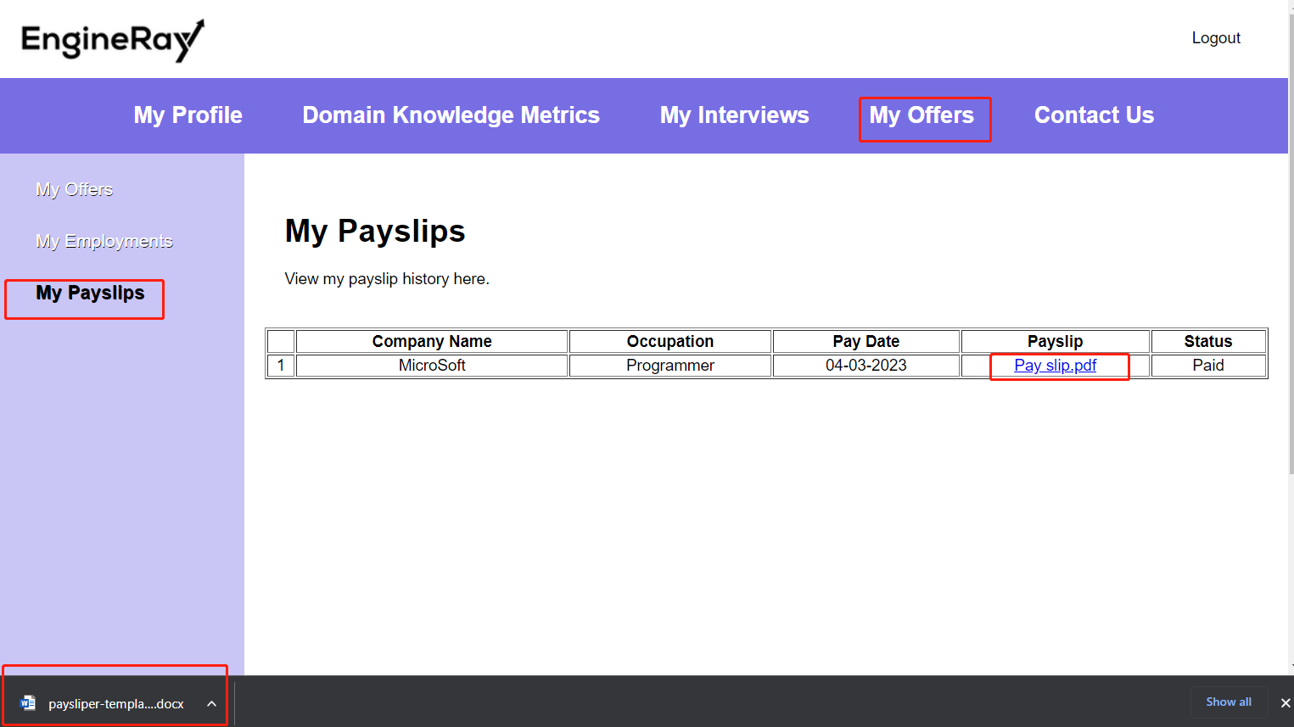

(Figure 42. View/Download the pay slip in the “**My Payslips**” page)